Income Mobility in China:
Main Questions, Previous Evidence, and New Results

Gary S. Fields
Cornell University and IZA
gsf2@cornell.edu

Cathy Gong
Australian National University
cathy.gong@anu.edu.au.

Xin Meng
Australian National University
xin.meng@anu.edu.au

Yang Song
School of Economics, Renmin University of China
ys337@ruc.edu.cn

Shuang Zhang
University of Colorado, Boulder
shuang.zhang@colorado.edu

Abstract
The international literature presents studies of macro mobility (how much income mobility is there in the economy?) and micro mobility (which individuals experience movements of what magnitudes and what are the correlates of these movements?). In China too, both macro mobility and micro mobility studies have been conducted. This paper reviews previous Chinese studies and then provides new micro mobility evidence for the 2000s. The main results of the mobility analysis are that 1) in the most recent data, earnings changes were unconditionally divergent but conditionally convergent in yuan, 2) earnings changes were convergent in yuan earlier (in the 1990s), both unconditionally and conditionally. In addition, all panels exhibit weak convergence, both unconditionally and conditionally - that is, the panel data analysis shows that it is always the initially low earners who exhibit the larger proportionate changes in earnings over time in China, not the initially high earners.

I. Introduction
As is well-known, China has experienced rapid economic growth. According to the official data published by National Bureau of Statistics, the average annual GDP growth rate in the past thirty years is 9.9% (1979-2010), 10.5% in the past twenty years (1991-2010), and 10.7% in the past ten years (2001-2010), the highest of any country in the world.
The traditional way of measuring the distributional consequences of economic growth is to use data from comparable cross sections to calculate various measures of inequality (relative) and poverty (absolute). Studies following the more traditional methodology have reached two principal conclusions. First, poverty in China has fallen dramatically. And second, relative income inequality in China has risen sharply. Specifically, the proportion of the population living below $1.25 per day (in 2005 PPP dollars) decreased from 84% in 1981 to 13.1% in 2008, and the nation-wide Gini coefficient of individuals' annual income increased from 0.371 in 1997 to 0.474 in 2012. Urban-rural inequality has also increased substantially in China (Table 1).
Table 1 Average Real Annual Labor Income (yuan)
Year | Rural | Urban | Ratio(U/R)
1995 | 2766 | 5348 | 1.93
2000 | 3723 | 9333 | 2.51
2005 | 5003 | 18200 | 3.64
2007 | 6323 | 24721 | 3.91
2008 | 7265 | 28898 | 3.98

Notes: The data above for rural workers come from household surveys in the rural area, while the urban data only cover workers in registered establishments in the urban area of China, including state-owned enterprises, private firms, government agencies, and foreign-owned enterprises. Labor income comprises wages and supplementary labor income and is defined as all compensation paid to employees. Source: Song (2013), calculated from data in the Chinese Statistical Yearbook, various years.

A newer approach in the development literature is to approach the distributional consequences of economic growth by using panel data (that is, following the same households or individuals over time) to analyze income mobility. Compared to the ample literature on static income inequality in China, research on income mobility is still in its infancy.
In this paper, we pose what we see as the main questions on income mobility in China, review the evidence to date on these questions, and then present the results of new analysis of micro mobility.

II. Review of the Literature
- Macro mobility and micro mobility
In China as elsewhere, income mobility has been studied at two levels. Macro mobility studies address the entire economy. Typical macro mobility questions include, “how much mobility of a given kind is there in the economy at any given time?” and “how has the amount of mobility of that kind changed over time?” On the other hand, micro mobility studies examine patterns of income change over time for different individuals or groups. Typical micro mobility questions are, “how much directional income movement has been experienced by individuals with different personal or job characteristics?” and “who gains more over time, those individuals who started in the top part of the income distribution or those who started at the bottom?”

- Principal data sets for carrying out mobility analysis
Empirical studies in China have been carried out using three main data sets. The China Household Income Project Survey (CHIPS) is a nationally representative survey including both rural and urban China. These surveys were conducted in 1988, 1995, 2002, and 2007. Each survey included current and retrospective questions on each household’s income and consumption in the previous four years – for example, in the 2002 survey, households reported their recollections of total income in 1998, 1999, 2000, 2001, and 2002. A second data set is the China Health and Nutrition Survey (CHNS), which is a panel data set conducted in nine waves (1989, 1991, 1993, 1997, 2000, 2004, 2006, 2009, and 2011 in urban and rural areas in nine provinces. The CHIPS and the CHNS, in addition to providing information about incomes, also include detailed information on household and individual characteristics. A third data set is the Urban Household Income and Expenditure Survey (UHIES), which is an annual survey conducted by the National Bureau of Statistics in urban areas throughout China. Households in the UHIES are re-surveyed once or twice depending on the year. Our sample in the analysis below includes nine one-year panels from 1992-1993 to 2005-2006 as well as three two-year panels (1994-1996, 1997-1999, and 2002-2004).

- Review of macro mobility studies
Macro mobility studies ask two main questions. The first is: how much mobility is there in the economy at present? The second is: how has the amount of mobility in the economy changed over time?
It is important to recognize that there is not one aspect of macro mobility; rather, there are six different concepts, each of which can be measured using alternative indices (Fields, 2007). Time-independence measures gauge how dependent current income is on past income. On the other hand, movement measures address a different issue: in comparing some aspect of the same individuals’ incomes between one year and another (their incomes in inflation-adjusted yuan, for example), how much income movement has taken place? The various movement indices in the literature may usefully be categorized into five groupings or concepts ('concepts' because they are different underlying entities, not alternative measures of the same underlying entity). Positional movement (or 'quantile movement') is about the movement of individuals among various positions (quintiles, deciles, or centiles) in the income distribution. Like positional movement, share movement is relative but in a different way. Share movement takes place if and only if an individual's income rises or falls relative to the total or relative to the mean. Another concept is non-directional income movement (also called 'flux'), which gauges the extent of fluctuation in individuals' incomes. Income changes are measured but the direction of change (positive or negative) is ignored. When the direction of change is considered, we have the concept of directional income movement. Finally, income mobility as an equalizer of longer-term incomes compares the inequality of recipients’ incomes over a number of periods with the inequality of incomes measured at a single point in time.
These six concepts are as different from one another as the different aspects of income distribution are. No researcher would say “I am doing an income distribution study,” nor would researchers believe that they are measuring the same underlying entity when they calculate GNP per capita, median household income, the Gini coefficient, Theil's index, the P-alpha class, and the Sen index. (If these income distribution indices are unfamiliar to you, the first two measure the location of the income distribution, the second two measure inequality in the distribution of income, and the final two measure income poverty.) Yet, mobility researchers in China have calculated indexes of time independence, positional movement, share movement, non-directional income movement, directional income movement, and income mobility as an equalizer of longer-incomes and presented them as though one index is measuring the same income mobility concept as another.
The macro mobility literature on China has produced the following major results:
Starting with studies of mobility at a single point in time, Khor and Pencavel (2006, 2010) found that the levels of positional movement and time-independence were quite high in urban China in the first half of the 1990s. Moreover, these mobility levels in China were reported to be greater than those in the United States and other developed countries. Wang (2005) showed that income mobility helped to equalize longer-term incomes relative to initial income in the 1990s in both rural and urban China. Shi, Nuetah, and Xin (2010) examined changes in the Gini index of mobility (which amalgamates positional movement and directional income movement) as well as positional movement in rural China and found more mobility using both measures as the mobility period is lengthened. Wagstaff (2009) used a method devised by Jenkins and Van Kerm (2006) to relate panel changes in average income from 1991-1997 to 2000-2004 to the extent of positional movement (termed “reranking”) and the pro-poorness of economic growth. Summarizing the literature, Shi, Liu, Nuetah, and Xin (2010) conclude: “Our results are contrary to the notion that people remain frozen in their place in the hierarchy of earnings.”
Turning to studies of mobility at different points in time, Nee (1994) found that positional movement in rural China was higher in the 1983-89 period than it had been in the 1978-83 period, which he interpreted as showing that “institutional change resulted in a dramatic shake-up of the rural stratification order.” Ding and Wang (2008) found that two-year non-directional income movement “remained at a high level” from 1989 to 2000 and that in each period more non-directional income movement was accounted for by exchange mobility than by growth and dispersion effects combined. On the other hand, Wang (2005), Yin, Li, and Deng (2006) and Jiang, Liu, and Zhang (2009) calculated measures of various mobility concepts - including time independence, positional movement, and income mobility as an equalizer of longer-term incomes relative to initial incomes – and found that all fell over time in both rural and urban China.

- Review of micro mobility studies
Micro mobility studies ask the question, which individuals or groups have more income mobility than others? The dependent variables in these studies are alternatively change in income in real yuan, change in log-income (real), and change in position (in quintiles, deciles, or centiles).
It is useful to separate out two types of micro mobility studies. Unconditional micro mobility studies examine such individual correlates of income change as initial income, gender, education, geographic location, and Communist party membership one variable at a time. Conditional micro mobility studies gauge the effect of one correlate controlling for the role of others.
Two studies to date have investigated unconditional micro mobility in China, both rural and urban. Two of these studies used data from the 1991-1995 period. Yin, Li, and Deng (2006) found that people with higher average incomes from 1991-1995 had smaller increases in log-incomes between 1991 and 1995. Along similar lines, Khor and Pencavel (2006) found that people with lower income percentile in 1991 and those with a lower percentile of average income over the 1991-1995 period had larger increases in log-income from 1991 to 1995. The finding of larger increases for the initially lower income people is termed “unconditional convergence” in the literature. When log-income is the dependent variable as was the case in these two studies, a finding of unconditional convergence means that the lower-income people had larger percentage changes in income over time than higher-income people did; in the literature, this pattern is called weak convergence. The international literature has also tested for strong convergence: whether the lower-income people had larger income changes in yuan than higher-income people did. Strong convergence has been found in China for both 1991-1995 and 1998-2002 using the CHIPS data (Fields and Zhang, 2007).
The Yin, Li, and Deng (2006) study also used CHIPS data from the 1998-2002 period, in their case to study convergence in log-incomes (“weak convergence”). They found a striking reversal: those with higher average income in yuan from 1998-2002 had significantly larger increases in log-incomes (and therefore much larger increases in incomes in yuan), in contrast to the 1991-1995 period, in which those with higher average incomes had significantly smaller increases in log-income. The switch from unconditionally convergent log-income changes in the earlier period to unconditionally divergent log-income changes in the later period is a major finding, clearly worthy of further study using other data sets and other time periods.
Turning now from unconditional to conditional micro mobility, we are aware of two studies of this issue, and both are limited to rural areas. Using data from ten provinces in rural China, Zhang, Huang, and Mi (2006) divided their sample of households into eight groups ranging from bottom 5% of the income distribution to top 5%. Their conditional mobility analysis involved running a multinomial logit model in which the dependent variable was the number of income groups moved (ranging from -2 to +2) from one period to the next. The explanatory variables included the household’s retrospective reports on previous income in the earliest year asked and in the year preceding the survey as well as time-varying household characteristics (dependency ratio, educational attainment, technical efficiency in crop production, the importance of agricultural income in total income, and the ratio of levied fee expense to the total expense of the household) and time-invariant household characteristics (whether the household head is a Communist Party member or a cadre member and whether the household rented in land or rented out land). They found that households in the lower income groups last year had statistically significantly greater upward positional movement, i.e., conditionally convergent mobility. We suspect that this result was guaranteed by choosing the change in positions as the dependent variable. However, the effect of initial income position on positional movement was statistically insignificant. This result might be caused by the high correlation between income position in quantile in the initial year and last year, when they are both controlled together with other variables on the right hand side.
The other conditional micro mobility analysis is that of Shi, Liu, Nuetah, and Xin (2010). These authors found statistically significant conditional convergence when initial reported income is used as a regressor and a statistically insignificant result when predicted income is used instead.
A number of micro mobility questions remain open. On the subject of unconditional micro mobility, most of the existing studies have analyzed the changes in log-income and the changes in positions. Only Fields and Zhang (2007) has analyzed the changes in income in yuan as opposed to log-yuan, but it is based on the CHIPS, which presents measurement error problems, as detailed below. The previous literature lacks a mobility profile of changes in income in yuan – that is, how the average income change varies with individual characteristics such as the worker’s education level (primary school or less, secondary school, high school or vocational school, professional school, or college and above). Another gap in existing knowledge is how these patterns have changed over time in the course of China’s rapid economic growth.
Two parallel questions arise for conditional micro mobility: what are the conditional determinants of income change in yuan at present, and how have these conditional determinants changed over time? We present results on these two questions below.

- A word on poverty dynamics
Before concluding this literature review, we would briefly mention the literature on poverty dynamics in China.
First, panel studies have found substantial movements between poverty and non-poverty in China (Jalan and Ravallion, 1998; McCulloch and Calandrino, 2003; Ravallion and Chen, 2007; Duclos, Araar, and Giles, 2010).
Second, poverty has been found to have a substantial transient component. Jalan and Ravallion (1998) developed a method for measuring chronic and transient poverty and estimated that transient poverty accounted for around three-quarters of total poverty in rural China. A newer method proposed by Duclos, Araar, and Giles (2010) produced a much smaller estimate: about one-quarter of total poverty in rural China being due to transient factors.
Third, a significant number of those not in poverty to begin with are vulnerable to falling into poverty. In a study of rural Sichuan province, McCulloch and Calandrino (2003) found a high vulnerability of falling into poverty between 1991 and 1995. Over 30 per cent of households fell below the consumption poverty line at some stage.

III. New Analysis of Micro Mobility in China
As we have just seen, panel data analysis has proved informative in China. In what follows, we present some new micro mobility results.
- Our contributions
Most of the studies reviewed in Section II analyzed changes in household income. A notable exception is Khor and Pencavel (2006), who studied individual income. In the analysis that follows, we examine changes in individual labor market earnings from one survey round to the next.
In this section, we pick up where the micro mobility results reviewed in the previous section left off and ask: in the 2000s which individuals in urban China experienced the largest earnings gains? This question may be answered by looking at the pattern of earnings changes in yuan for different initial earnings groups (which tells us about strong convergence or divergence) and in log-yuan (which tells us about weak convergence or divergence).
As noted in the introduction, ample research has shown that relative income inequality in China has been rising steadily over time. Income inequality figures are based on anonymous data – that is, cross sections in which the sampling frame is kept the same from survey to survey but different households and individuals are surveyed in different rounds. However, the income mobility question we are posing here requires that the same individuals be followed over time and their incomes measured at two or more dates. The income changes over time for panel persons belonging to different groups (for example, earners in different quintiles of the initial earnings distribution) can then be averaged and compared.
It might be hypothesized that those panel persons who gained the most in China were those who started in the best economic positions to begin with – what we have called divergent mobility. Divergent mobility might be hypothesized to have taken place in China for several reasons. First, income inequality has been increasing over time in China among anonymous people, and if the same individuals occupied the same positions in the income distribution in an earlier year and later year, those panel people at the top would have gained more than those at the bottom. But of course, this conjecture assumes that everybody remained in the same position where they started, which we know from previous studies is not the case in China (or anyplace else). However, if the movements among positions in the income distribution were not too large, divergent mobility might still be found. Second, we know that China has experienced labor market twist, in the sense that the labor market has tightened the most for those at the top end of the skills distribution. In the cross section, real labor market earnings in China have risen the most for workers in the highest educational groups (Chi, Freeman, and Li, 2012; Meng, 2012). This pattern of earnings changes by education, when coupled with fairly modest rates of movement across occupations (for example, most of those who started as farmers remained farmers and did not become factory workers) leads to the expectation that those individuals who started high in the income distribution would have experienced the largest income gains over time. Third, there are positive feedback loops, which Nobel laureate James Meade (1976, p. 155) called “self-reinforcing influences which help to sustain the good fortune of the fortunate and the bad fortune of the unfortunate.” In the Chinese context, it may be that those who enjoyed the best connections to begin with – say, because they were Communist party members – would have been the ones who enjoyed the largest earnings gains over time.
There are, however, several reasons to expect the opposite: that income mobility in China might have been convergent. First, some but not all of the earlier studies in China reported statistically significant convergence in the 1990s; see Section II.D for details. Second, studies of other developing countries usually show statistically significant convergence, in many cases at the same time as cross-sectional income inequality has been rising, as it has been in China. And third, a number of standard econometric specifications hypothesize regression to the grand mean, either because of iid error terms or because of a first-order autoregressive process; an example is Khor and Pencavel (2006).
The research results reported below make several contributions to the literature on income mobility in China.
One contribution is that we have been fortunate to have gained access to a panel data set with less measurement error than the data sets used by us and others in previous research. The dataset we use here is the Urban Household and Income Expenditure Survey (UHIES), an annual survey conducted by China’s National Bureau of Statistics in urban areas throughout China since 1986. Over 20,000 households are surveyed every year. UHIES has a three year rotation rule, whereby a sample is interviewed in year t, two-thirds are re-surveyed in year t+1, and one-third are re-surveyed in year t+2. A fresh sample is then drawn in year t+3. One-year and two-year panels are then available. In each year the household is surveyed, the survey asks each household member the incomes, income sources (labor income, financial income, transfer income, etc.), employment status, occupation, and time-invariant characteristics including age, gender, education, and work experience. Survey households keep detailed records of income and expenditure on a daily basis, and survey enumerators revisited their household regularly.
The geographic coverage of the UHIES is urban areas in sixteen Chinese provinces. Our sample includes individuals between sixteen and sixty years of age who were in the labor force in both years of the panel. We use individual labor income – including salary, subsidies, and bonuses – to measure labor market earnings. To deflate the price impact across provinces and over time, the data are adjusted in accordance with each province’s CPI for urban China over the study period, so all earnings are real earnings.
Gong (2008) previously used the UHIES to study income mobility. Our work differs from hers in that we ask a larger set of questions, use two-year panels in addition to one-year panels, and are able to analyze a longer and more recent time span than she could.
The fact that we have repeated observations on labor market earnings for the same individuals over time and that these measurements are authenticated by survey enumerators visiting the sampled households repeatedly greatly reduces measurement error compared to the CHIPS, in which respondents were asked to report what their incomes were one, two, three, and four years ago, producing data subject to serious recall error, which is not the case for the UHIES.
Finally, a lot of the mobility analysis in China is based on the analysis of the China Health and Nutrition Survey (CHNS). The CHNS is problematical for studying income mobility, in that the missing income values in a given year were filled in with the value in an adjacent year if the individual or household remained in the same occupation. This way of constructing missing income values assumes away any changes in individual or household incomes which might have taken place within the same occupation. Another problem with the CHNS is that the rates of return to education estimated from the CHNS urban sample are typically less than half of those obtained from other data sets (Gong and Meng, 2008). On the other hand, the UHIES data we are using has one significant limitation, which should be borne in mind. It is limited to households with urban registrations (hukou); migrant households in urban areas and rural households are not included in our data set.
A second contribution of our work is that we are able to go as far forward in time as the 2002-2004 period to analyze two-year mobility among panel people and 2005-06 to analyze one-year mobility. Our analysis is therefore more recent than other studies before ours. We are also able to back in time to 1992, thus supplementing the current data with historical data.
A third contribution of our work is that we examine the divergence/convergence question using both yuan and log-yuan. Previous studies of China have examined only one or the other, but here we present the results of both side by side.
Fourth, our panel analysis asks which groups of Chinese workers benefited how much from economic growth using a number of different grouping variables. As in other studies, we use quintile in the initial reported earnings distribution as a principal indicator of initial position. However, in addition, we look at workers grouped differently: by gender, by age group, by education category, and by sector of employment in initial and final year. As far as we know, the resultant mobility profile is a first for China, and it enables us to determine whether the pattern found for initial earnings also holds for other measures of labor market advantage.
A fifth contribution of our analysis is that it is both unconditional and conditional. It is not necessarily the case that the group with higher earnings changes on average also had higher earnings changes when controlling for other factors. Below, we explore whether this is or is not the case for China.
A sixth and final contribution is that we subject our results to a number of robustness tests, which we find confirm the qualitative results of the core specification.

- New results: core analysis
This section presents the core analysis of the UHIES data. We relate the change in real earnings in yuan in the most recent two-year panel (2002-2004) to a variety of correlates including initial earnings, gender, age group, education group, and sector of employment. The reason for giving the greatest attention to the two-year-panel results is that they are less sensitive than one-year panels to short-term changes (temporary illness or unemployment, for example). In subsequent sections, we will present robustness tests using earlier two-year panels, all one-year panels, and changes in log-yuan rather than yuan .
B.1. Two-year earnings change as a function of initial earnings
We begin by looking at the change in mean and median earnings between 2002 and 2004 for individuals grouped according to quintile of initial earnings (Table 2). We see that mean earnings changes are higher for individuals who started in the two higher earnings quintiles than those who started in the three lower ones. We see also that median earnings changes rise monotonically. Thus, for initial earnings quintile, we have unconditionally divergent mobility for 2002-2004.

Table 2 Mean and Median Earnings Changes, by Initial Earnings Quintile: 2002-2004 Panel
by initial earnings | mean | sd | obs | median
Lowest Quintile | 1234 | 2996 | 3281 | 275
Quintile 2 | 1001 | 3170 | 3281 | 563
Quintile 3 | 1201 | 3896 | 3282 | 794
Quintile 4 | 1558 | 4049 | 3281 | 1280
Highest Quintile | 2188 | 7950 | 3281 | 1671

B.2. Complete mobility profiles
Table 3 presents complete profiles of mean earnings change for the most recent two-year panel. To interpret these patterns, it is necessary to know which groups are the highest earners. They are: workers in the highest initial earnings quintile, males, workers under age 45, workers with higher levels of education, and public sector workers.

Table 3 Earnings Change Profile: Two-Year Panel, 2002-2004
 | mean | sd | obs
by initial earnings
Lowest Quintile | 1234 | 2996 | 3281
Quintile 2 | 1001 | 3170 | 3281
Quintile 3 | 1201 | 3896 | 3282
Quintile 4 | 1558 | 4049 | 3281
Highest Quintile | 2188 | 7950 | 3281
by gender
male | 1747 | 5385 | 8862
female | 1072 | 3944 | 7544
by age group
up to 30 | 1523 | 4559 | 2594
31-44 | 1598 | 4567 | 8736
45 and older | 1115 | 5238 | 5076
by education
primary | 226 | 3654 | 390
middle school | 753 | 4048 | 4192
high school | 1249 | 4591 | 6905
semi-college | 2125 | 5117 | 3622
college | 3083 | 6447 | 1297
by sector change
always public | 1890 | 4375 | 11157
public to private | 869 | 5022 | 557
always private | 1500 | 5276 | 2925
private to public | 2880 | 5980 | 280
Experienced unemployment | 98 | 4455 | 1461

Comparing earnings changes for these different groups, we see in each case that workers in the most favored groups to begin with are the ones that enjoyed the largest earnings changes in yuan over time. This is further evidence of divergent mobility in recent years in China – a result that differs from what is found in most other developing countries.
B.3. Comparing the panel results with anonymous results
How do the panel results just presented compare with cross-sectional patterns of earnings changes? For example, how do the earnings changes of those panel persons who started in each earnings quintile and who may have changed quintiles over time compare with the earnings changes of the anonymous persons who were in a given earnings quintile in the initial and final year but who may be different people? Table 4 compares the panel changes with the cross sectional changes.

Table 4 Panel and Cross Sectional Earnings Changes in the 2002-2004 Panel
 | Mean
 | Panel Changes | Cross Sectional Changes
by initial earnings
Lowest Quintile | 1234 | -46
Quintile 2 | 1001 | 503
Quintile 3 | 1201 | 988
Quintile 4 | 1558 | 1682
Highest Quintile | 2188 | 4056
by gender
male | 1747 | 1746
female | 1072 | 1072
by age group
up to 30 | 1523 | 827
31-44 | 1598 | 1514
45 and older | 1115 | 980
by education
primary | 226 | 196
middle school | 753 | 767
high school | 1249 | 1221
semi-college | 2125 | 2090
college | 3083 | 3042
by sector change
always public | 1890 | 1571.55
public to private | 869 | 458.95
always private | 1500 | 1359.17
private to public | 2880 | 2471.77

For characteristics that can change substantially over time – most importantly, earnings itself – we find that the results are quite different. Consider the lowest earnings quintile. In the first column, which looks at the persons who started in the lowest earnings quintile and who may have moved up to a higher quintile, the mean earnings change in two years was a gain of 1234 yuan. On the other hand, looking at the second column, which compares cross sections, we see that the anonymous persons in the poorest quintile were on average 46 yuan poorer in 2004 than they had been in 2002. Put differently, the people who started in the poorest quintile and whom we follow over time experienced substantial earnings gains; but it was also the case that the individuals who ended up in the poorest quintile in China were even poorer than the (different) individuals who started there. Another comparison goes in the opposite direction: for the richest quintile, we see that the earnings gain for the anonymous persons in the top quintile were twice as high on average as those for the panel persons.
Why are the anonymous changes and the panel changes so different? The answer is that quite a lot of individuals make substantial moves within the earnings distribution over time. We can see these transitions in two ways.
One is to examine movements across earnings quintiles (Table 5). Such a quintile mobility matrix displays the extent of movement across the five quintiles in the panel but not movements within them. We see two main patterns. First, conditional on starting in a given earnings quintile, the likelihood of remaining there varies from 0.5 for the three middle quintiles to 0.7 for the highest and lowest quintile – that is, somewhat more than half the panel people remain in the same earnings quintile. Turning this finding around gives us our second finding: about 40% of the panel people changed earnings quintile. Most of these changes were from one quintile to an adjacent one, but there were those who changed quite a lot.

Table 5 Quintile Transition Matrix, 2002-2004, %
 | Lowest Quintile | Quintile 2 | Quintile 3 | Quintile 4 | Highest Quintile
Lowest Quintile | 0.73 | 0.20 | 0.05 | 0.02 | 0.00
Quintile 2 | 0.21 | 0.53 | 0.20 | 0.04 | 0.02
Quintile 3 | 0.05 | 0.20 | 0.51 | 0.19 | 0.04
Quintile 4 | 0.02 | 0.03 | 0.21 | 0.53 | 0.20
Highest Quintile | 0.02 | 0.01 | 0.03 | 0.21 | 0.73

Another way of seeing the extent of earnings movement is to examine two diagrams. For the 2002-2004 China panel, we have taken those individuals who were at the fifth, twenty-fifth, fiftieth, seventy-fifth, and ninety-fifth percentiles of each of the five earnings quintiles in 2002. Those twenty-five individuals’ 2002 earnings are depicted as dots in the top half of Figure 1; those same individuals’ 2004 earnings are depicted as dots in the lower half of the figure. We see that in both years, most workers are concentrated in 8 to 11 log-earnings range but a few are well outside that range. What we cannot see in Figure 1 is how earnings changed for these twenty-five individuals. We can see this, though, by looking at Figure 2. What we see there is that most of these earners continued to earn approximately what they had previously, but there were a few large changers. Of the twenty-five people depicted, two zero-earners became positive earners, one positive earner became a zero-earner, one initially-high earner became the highest earner, and the initially-highest earner moved down below several others.

Figure 1 Earnings Distribution for 25 Illustrative Individuals in
2002-2004, Presented Anonymously
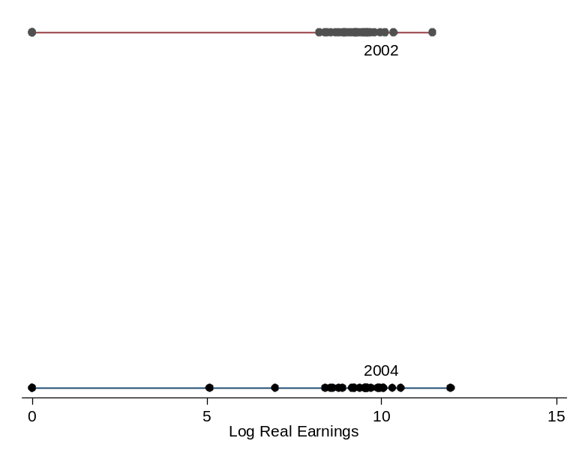

Figure 2 Earnings Distribution for 25 Illustrative Individuals in
2002-2004, Presented as a Panel
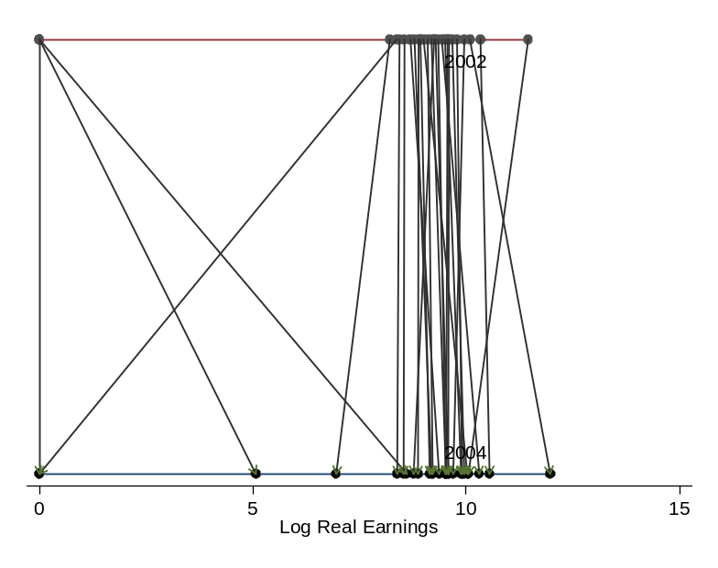

In summary, most workers in China did not experience major earnings changes, but a significant number did.

B.4. Correcting for measurement error
A well-established result in the income mobility literature is that when relating the change in income over time Y_{t} – Y_{t-τ} to initial income Y_{t-τ}, the mismeasurement of Y_{t-τ} affects both the dependent variable Y_{t} – Y_{t-τ} and the independent variable Y_{t-τ} but in opposite directions, producing an attenuation bias (e.g., Deaton, 1997). One way of overcoming this bias is to replace the independent variable Y_{t-τ} by the income level in some other year Y_{t'}, which we do in this context by relating the change in earnings between 2002 and 2004 to the earnings level in 2003.
Profile results are presented in Table 6. We find that among panel people, as we move from the lowest 2003 earnings quintile to the highest 2003 earnings quintile, mean and median earnings change from 2002 to 2004 both increase monotonically.
Table 6 Mean and Median Earnings Changes, by 2003 Earnings Quintile: 2002-2004 Panel
by 2003 earnings quintile | mean | sd | obs | median
Lowest Quintile | 199 | 2714 | 3282 | 0
Quintile 2 | 590 | 2889 | 3281 | 378
Quintile 3 | 1022 | 3470 | 3281 | 886
Quintile 4 | 1651 | 4181 | 3281 | 1426
Highest Quintile | 3721 | 7858 | 3281 | 2984

We then linearize and regress earnings change from 2002 to 2004 on 2003 earnings. The results with 2003 earnings as the independent variable are essentially identical to those with 2002 earnings as the independent variable, with a statistically significant positive coefficient appearing for each (Table 7). In sum, the finding of divergence in the 2000s is robust to these corrections for measurement error.
Table 7 Unconditional Earnings Change Regressions
in the 2002-2004 Panel
 | OLS
real_earnings2002 | 0.06***
 | (0.006)
real_earnings2003 |  | 0.05***
 |  | (0.0004)
Observations | 16,406 | 16,406

B.5. Testing for conditional convergence/divergence
All of the results in this section so far have examined the unconditional relationship between earnings change in yuan Y_{t} – Y_{t-τ} and initial earnings Y_{t-τ} . Let us now condition on other correlates of earnings change.
To test for conditionally convergent or divergent mobility based on initial earnings, we run a multiple regression of the form
${ΔY}_{i,t}=α+β_{1}Y_{i,t−τ}+β_{2}Z_{i}+β_{3}X_{i,t−τ}+β_{4}X_{i,t}+ε_{i,t}$.
Here, the dependent variable${ΔY}_{i,t}$is the change of earnings in yuan between the initial year t-τ and final year t. On the right hand side, $Y_{i,t−τ}$denotes earnings in the initial year, $Z_{i}$ denotes time-invariant individual characteristics like age, gender, race, and education, and$X_{i,t−τ}$ and $X_{i,t}$denote time-varying employment characteristics in years t-τ and t respectively. The coefficient$β_{1}$estimates whether mobility is strongly conditionally convergent or divergent. If $β_{1}<0$, there is strong conditional convergence; if $β_{1}>0$, there is strong conditional divergence; and if$β_{1}=0$, the pattern of earnings change is neutral with respect to initial earnings, i.e., income recipients in different parts of the initial earnings distribution gain essentially the same amount in yuan (and hence those with initially low earnings gain more in percentage terms than those with higher initial earnings).
The results for the 2002-2004 period using OLS are reported in Table 8. We obtain two major results. On the one hand, the groups with characteristics associated with higher earnings and earnings changes – men, the better-educated, the young, and those who moved into the public sector – had the most positive conditional earnings changes. On the other hand, controlling for these characteristics, higher initial earnings are associated with significantly lower earnings changes. We interpret these conditional results as follows. The gender, age, education, and sector variables can be understood as determinants of a worker’s permanent earnings. In the presence of these variables, initial year real earnings can be understood as an indicator of a worker’s transitory earnings. The coefficient on initial year real earnings can then be interpreted as the effect of starting out with earnings above what they “should” be. The negative and statistically significant coefficient on this variable can be understood as signifying that earnings in China tend to revert to the worker’s conditional mean.
Table 8 Conditional Earnings Change Regressions
in the 2002-2004 Panel
 | OLS
real_earnings2002 | -0.013**
 | (0.006)
male | 438.737***
 | (74.808)
age_3144 | -390.194***
 | (105.933)
age_45 | -648.624***
 | (81.66)
Junior high school | 13.602
 | (238.55)
Senior high school | 295.77
 | (236.56)
Semicollege | 919.308***
 | (245.965)
Head College | 1754.261***
 | (270.767)
public02_public04 | 3757.649***
 | (136.835)
public02_private04 | 2922.655***
 | (231.33)
private02_public04 | 4896.269***
 | (301.038)
private02_private04 | 3626.941***
 | (149.885)
Observations | 16,406
R-squared | 0.073

C. New results: other panels and specifications
C.1. Changes in yuan for earlier two-year panels
We now repeat the analysis of Section B for earlier two-year panels. We find that the unconditional and conditional divergence patterns in the 2002-2004 panel are not found in the earlier two-year panels. Instead, for 1994-1996 and 1997-1999, the results show unconditional convergence in yuan in the mobility profile (Table 9) and in bivariate linear regressions (Figure 3). Figure 3 also shows conditional convergence in yuan for the earlier two-year panels. (Note: In this and the other figures, the dates indicate the initial year of the panel.)

Table 9 Mean Earnings Changes, by Initial Earnings Quintile:
All Two-Year Panels
 | 2002-2004 |  |  |  | 1997-1999 |  |  |  | 1994-1996
by initial earnings | mean | sda | obs |  | mean | sda | obs |  | mean | sda | obs
Lowest Quintile | 1234 | 2996 | 3281 |  | 890 | 1840 | 341 |  | 827 | 2191 | 662
Quintile 2 | 1001 | 3170 | 3281 |  | 601 | 1786 | 342 |  | 746 | 2039 | 663
Quintile 3 | 1201 | 3896 | 3282 |  | 418 | 2362 | 342 |  | 828 | 2410 | 663
Quintile 4 | 1558 | 4049 | 3281 |  | 455 | 3295 | 342 |  | 29 | 3051 | 663
Highest Quintile | 2188 | 7950 | 3281 |  | 35 | 4620 | 342 |  | -571 | 6248 | 662
P Value of F-test |  | 0.0000 |  |  |  | 0.0000 |  |  |  | 0.0000

Figure 3 Tests of Strong Convergence: Two-year Panels
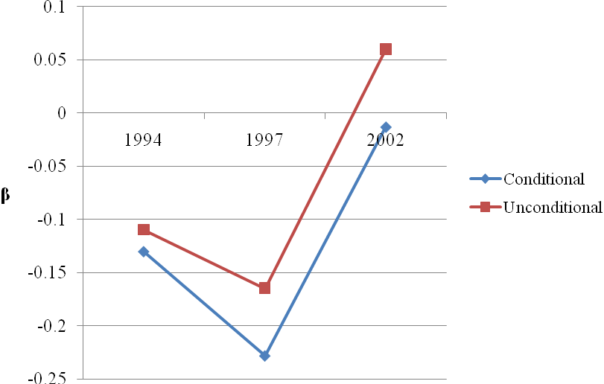
Note: All of the regression coefficients are statistically significant at least at 95% level, and some of them are significant at 99% level.

C.2. Changes in yuan for the one-year panels
We turn now to the one-year panels, which start in 1992-1993 and end in 2005-2006. Table 10 presents a mobility profile for the 2005-2006 panel. We see that the results match those for the 2002-2004 panel qualitatively in that the persons with the largest earnings gains are those in the highest initial earnings quintile, males, younger workers, the better-educated, and public sector workers.
Table 10 Earnings Change Profile: One-Year Panel, 2005-2006
 | mean | sd | obs
by initial earnings
Lowest Quintile | 1145 | 2919 | 5869
Quintile 2 | 1121 | 3408 | 5868
Quintile 3 | 1335 | 3872 | 5869
Quintile 4 | 1251 | 4725 | 5868
Highest Quintile | 2102 | 15176 | 5868
by gender
male | 1536 | 7589 | 16252
female | 1210 | 7598 | 13090
by age group
up to 30 | 2105 | 16836 | 2001
31-44 | 1476 | 6543 | 16484
45 and older | 1130 | 6204 | 10857
by education
primary | 714 | 3419 | 815
middle school | 7416 | 935 | 4897
high school | 11149 | 1256 | 8388
semi-college | 6627 | 1734 | 6938
college | 3084 | 2237 | 10048
by sector change
always public | 1630 | 7529 | 17750
public to private | -2952 | 12355 | 375
always private | 1246 | 7925 | 9520
private to public | 447 | 6329 | 109
Experienced unemployment | -48 | 4643 | 1809

Turning to the regression coefficients, we also find non-robust results across the different panels (Figure 4).
Figure 4 Tests of Strong Convergence: One-year Panels
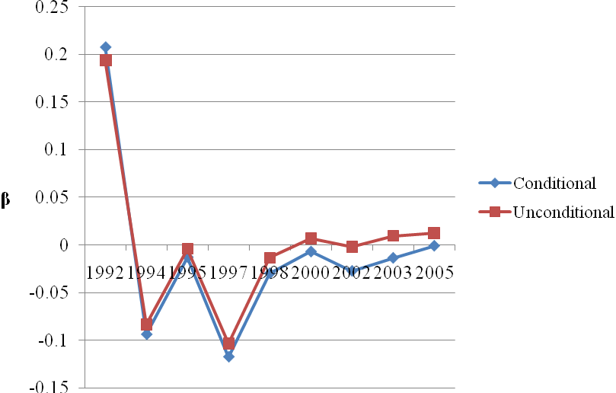
Note: Almost all of the regression coefficients are statistically significant at least at 95% level, and some of them are significant at 99% level. The only insignificant coefficient is found when testing the conditional convergence for 2005-2006, where the regression coefficient is -0.001 and the standard error is 0.004.

In the most recent one-year panel, a conditional regression of earnings change on initial earnings produces an insignificant coefficient. On the other hand, most of the earlier one-year panels show significant convergence, both unconditionally and conditionally. Only the 1992-1993 panel produces divergence, both unconditionally and conditionally. One possible reason for the convergent pattern in the 1990s is the dramatic labor market reform at that time. Previously, there had been no labor market; all workers had been assigned to jobs by local governments, schools, or communities (Fields and Song, 2013). In addition, the majority of workers in urban China were employed in the public sector with a lifetime employment system and relatively high wages. That is, high-income workers before the 1990s were those working in the public sector. Things changed quite dramatically especially starting in 1997, when China speeded up the reform of State Owned Enterprises. The objective of this reform was to shut down loss-making SOEs, and to encourage the development of the private sector along with a more flexible labor market (Meng, 2012). Since the watershed of 1997, the urban labor market has been reshaped with massive layoffs by SOEs (Song, 2013). The aggressive economic restructuring led to the layoffs of at least 30 million workers by 2004, mostly from the public sector (Cai, Park, and Zhao, 2009). That is, some of high-income workers prior to the reform lost their jobs in the state sector and became low-income people. In contrast, some of low-income workers prior to the reform may have obtained better job opportunities and thus earned high wages in the private sector with the rapid development of this sector.
It is noteworthy that the results turn around in the 2000s. We find unconditional divergent mobility in the 2000s compared to unconditional convergent mobility in the 1990s. This might be some evidence for positive feedback loops as mentioned above, in that workers in the most favored groups to begin with are the ones that enjoyed the largest earnings changes over time. Before the reform in the 1990s, income inequality was very low in China (Li et al., 2012). After the market-oriented reform in the 1990s, people who succeeded in grasping the new opportunities became very rich and were able to accumulate their advantages over time. In contrast, those who lost their jobs in the 1990s may have fallen into a low-income trap or even a poverty trap. This is consistent with the argument by Wang et al. (2012) claiming that most initially low income people remained poor over time in the 2000s.
C.3. Testing for weak convergence/divergence
All of the results presented so far have examined earnings changes in yuan, and therefore the tests have been for strong convergence/divergence. It is possible that different results might be gotten when the dependent variable is change in log-yuan, which approximates proportionate earnings change.
The unconditional equation run for this test is
$Δ\text{ln}Y_{i,t}=α'+β_{1}\text{'ln}Y_{i,t−τ}+ε'_{i,t}$.
The conditional equation is
$Δ\text{ln}Y_{i,t}=α'+β_{1}\text{'ln}Y_{i,t−τ}+β_{2}'Z_{i}+β_{3}'X_{i,t−τ}+β_{4}'X_{i,t}+ε'_{i,t}$.
The full regression results for the 2002-2004 panel appear in Table 11. The coefficients on initial log-earnings are presented in Figure 5 for the two-year panels and in Figure 6 for the one-year panels. All panels exhibit weak convergence, both unconditionally and conditionally. That is, the panel data analysis shows that it is always the low earners who exhibit the larger proportionate changes in earnings over time in China, not the high earners.
Table 11 Test for Weak Conditional Convergence
in the 2002-2004 Panel
 | OLS
ln (real_earnings2002) | -0.263***
 | (0.0058)
male | 0.073***
 | (0.007)
age_3144 | -0.015
 | (-0.015)
age_45 | -0.0092
 | (0.0117)
Junior high school | 0.0284
 | (0.0235)
Senior high school | 0.084***
 | (0.023)
Semicollege | 0.1617***
 | (0.024)
Head College | 0.225***
 | (0.026)
public02_public04 | 1.009***
 | (0.022)
public02_private04 | 0.9125***
 | (0.028)
private02_public04 | 1.108***
 | (0.035)
private02_private04 | 0.966***
 | (0.023)
Observations | 15,059
R-squared | 0.199

Figure 5 Tests of Weak Convergence: Two-year Panels
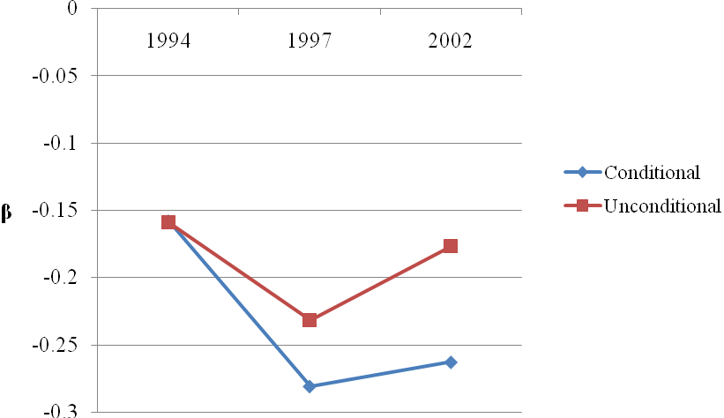
Note: All of the regression coefficients are statistically significant at least at 95% level, and some of them are significant at 99% level.

Figure 6 Tests of Weak Convergence: One-year Panels
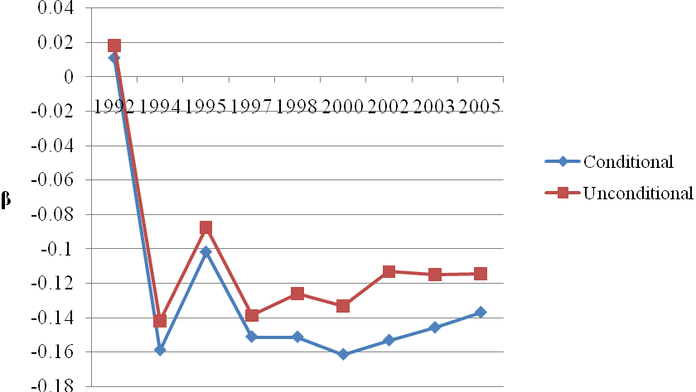
Note: All of the regression coefficients are statistically significant at least at 95% level, and some of them are significant at 99% level.

How can it be that the low earners exhibit the most positive proportionate earnings changes in the panel despite the rising cross-sectional earnings inequality in China? The answer, very simply, is that some of these low-earners moved up and out of the low-earning category while others who initially were not low-earners moved down and into that category; please look again at Figure 2 and Table 5. And how can it be that for a panel such as 2002-2004, earnings mobility is strongly divergent but weakly convergent? The answer is straightforward: the low earners enjoyed larger proportionate earnings gains but smaller earnings gains in yuan than did earners higher up in the earnings distribution.

IV. Conclusion
In this paper, we have used data from China’s Urban Household Income and Expenditure Survey (UHIES) to examine patterns of earnings changes among panel people in the course of China’s remarkably rapid recent economic growth. The main results of the mobility analysis are: in the most recent data, earnings changes were unconditionally divergent but conditionally convergent in yuan; earnings changes were convergent in yuan earlier (in the 1990s), both unconditionally and conditionally; all panels exhibit weak convergence, both unconditionally and conditionally - that is, the panel data analysis shows that it was always the low earners who exhibit the larger proportionate changes in earnings over time in China, not the high earners. At the same time, the Gini coefficient of individuals' annual income increased and the urban-rural earnings gap increased substantially.
The patterns of cross-sectional changes, proportionate changes in the panel, and changes in yuan in the panel all are true. However, they convey very different impressions. All of this goes to say that an analyst wanting to know which income groups have benefited the most from the economic growth that has taken place in China must decide which of these pieces of evidence to give the most weight to.

References
Cai, Fang, Albert Park, Yaohui Zhao, 2009. "The Chinese Labor Market in the Reform Era," in Loren Brandt and Thomas Rawski, eds., China’s Great Economic Transformation, Cambridge University Press.
Chen, Shaohua and Martin Ravallion, 2012. “More Relatively Poor People in a Less Absolutely-Poor World,” World Bank Policy Research Working Paper 6114.
Chi, Wei, Richard B. Freeman, and Hongbin Li, 2012. “Adjusting to Really Big Changes: the Labor Market in China, 1989-2009,” NBER Working Paper 17721, January.
Deaton, Angus, 1997. The Analysis of Household Surveys. (Baltimore: Johns Hopkins University Press for the World Bank).
Ding, Ning and Yougui Wang, 2008, “Household Income Mobility in China and its Decomposition,” China Economic Review, 19: 373-380.
Duclos, J-Y., A. Araar and J. Giles, 2010, "Chronic and Transient Poverty: Measurement and Estimation, with Evidence from China," Journal of Development Economics 91(2): 266-277.
Fields, Gary, 2007, "Income Mobility," Forthcoming in Lawrence Blume and Stephen Durlauf, eds., The New Palgrave.
Fields, G. S., and Zhang, S., 2007,. "Income mobility in China: Main questions, existing evidence, and proposed studies." Working Paper, Cornell University, ILR School.

Fields, Gary, 2010, “What We Know (and Want to Know) about Earnings Mobility in Developing Countries,” Cornell University, processed.
Fields, G. S., and Song, Y. 2013. "A theoretical model of the Chinese labor market." IZA Discussion Paper Series, No. 7278.
Gong, Cathy, 2008, “Household Income Mobility in Urban China, 1992-2001,” Working Paper, Australian National University.
Gong, Cathy and Meng, Xin, 2008, “Household Income Mobility and Its Determinants in Urban China 1992-2001”, presented at Brownbag Seminar, Economics Program, Australia National University.
Jalan, J. and M. Ravallion, 1998, "Transient Poverty in Postreform Rural China," Journal of Comparative Economics, 26: 338-357.
Jenkins, Stephen P. and Philippe van Kerm, 2006. “Trends in Income Inequality, Pro-Poor Income Growth, and Income Mobility,” Oxford Economic Papers, 58(3): 531-548.
Jiang, Jin-qi, Qiang Liu, and Guang-sheng Zhang, 2009, “The Income Mobility in Rural China: Measurement and Decomposition,” Proceedings of the 2009 International Conference on Public Economics and Management, Xiamen, China.
Khor, Niny and John Pencavel, 2006, “Income Mobility of Individuals in China and the United States”, Economics of Transition, 14 (3): 417-458.
Khor, Niny and John Pencavel, 2010, “Income Inequality, Income Mobility, and Social Welfare for Urban and Rural Households of China and the United States,” in Solomon W. Polachek and Konstantinos Tatsiramos, eds., Research in Labor Economics, Volume 30. Emerald Publishing Group, 61-106.
Li, H., Li, L., Wu, B., & Xiong, Y. 2012. "The end of cheap Chinese labor." The Journal of Economic Perspectives, 26(4), 57-74.
McCulloch, N. and M. Calandrino, 2003, "Vulnerability and Chronic Poverty in Rural Sichuan," World Development, 31(3): 611-628.
Meade, J. E. (1976). The Just Economy. London: Allen and Unwin.
Meng, Xin, 2012. “Labor Market Outcomes and Reforms in China,” Journal of Economic Perspectives, 26(4): 75-102.
Nee, Victor, 1994, “The Emergence of a Market Society: Changing Mechanisms of Stratification in China,” American Journal of Sociology, Vol 101, No.4: 908-949.
Ravallion, Martin and Shaohua Chen, 2007. "China's (Uneven) Progress Against Poverty," Journal of Development Economics, 82(1): 1-42.
Shi, Xuehua, Xiaoyun Liu, Alexander Nuetah, and Xian Xin, 2010. “Determinants of Household Income Mobility in Rural China,” China and World Economy, 18(2): 41-59.
Shi, Xuehua, J. Alexander Nuetah, and Xian Xin, 2010. “Household Income Mobility in Rural China: 1989-2006,” Economic Modelling 27: 1090-1096.
Song, Yang, 2013. Essays on the Chinese Labor Market. Unpublished Ph.D. Dissertation, Cornell University.
Tao, Yinghu, 2008, “On the Regional Income Mobility of Rural Residents in Jiangshu Province,” Journal of Nanjing Agricultural University (in Chinese), 8(3): 64-69.
Wagstaff, A., 2009, "Reranking and Pro-poor growth: decompositions for China and Vietnam. " Journal of Development Studies, 45(9), 1403-1425.

Wang, Haigang, 2005, "The Household Income Mobility and its Equalizing Long-term Income in China," Economic Research Journal (in Chinese), No. 1: 56-66.
Wang, Hongliang, Zhibiao Liu, Wenhua Sun, and Qizhi Hu, 2012,"Inequality of opportunities in China: an Analysis based on Income Mobility," The Journal of World Economy (in Chinese), 1, 114-143.
Yin, Heng, Shi Li and Quheng Deng, 2006, "Income Mobility in Urban China", Economic Research Journal (in Chinese), 10: 30-43.
Zhang, Qi, Jikun Huang and Jianwei Mi, 2006, "Income Inequality and Economic Mobility in Rural China: Who Can Move up the Income Ladder?" Working Paper, Northwestern University.

Information in available at: http://www.stats.gov.cn/english/statisticaldata/yearlydata/.
The poverty data are from Chen and Ravallion (2012). The Gini coefficients for inequality are from the National Bureau of Statistics, available at http://economy.caijing.com.cn/2013-01-18/112444588.html.
Other data sets with very limited geographic coverage have been used in some Chinese mobility research (e.g., McCulloch and Calandrino, 2003; Tao, 2008), but we do not include such studies in our literature review.
The periods are two to six years long, and incomes are averaged within each period.
Besides previous studies of China, unconditional convergence has been found in studies of Indonesia, South Africa, Venezuela, Tanzania, Peru, Argentina, Mexico, Nicaragua, the Philippines, and Albania. See Fields (2010) for details.
These are the most recent data now available. Newer data will be made available in the future.
Cf. footnote 5.

