When Can Experimental Evidence Mislead?

A Re-Assessment of Canada’s Self Sufficiency Project*

Chris Riddell

ILR School

Cornell University

and

W. Craig Riddell

Vancouver School of Economics

University of British Columbia

September 2015

*Preliminary and Incomplete*

* We thank John Abowd, David Card, David Green, Josh Gottlieb, Hilary Hoynes, Jesse Rothstein and Chris Walters for helpful comments. We also benefitted from comments of seminar participants at Berkeley, Santa Barbara, UBC, Brandeis, Minnesota, IZA/OECD/World Bank Social Safety Nets workshop in Paris, CLRSN workshop in Toronto, the IZA/IFAU Labour Market Policy Evaluation workshop in Uppsala, and the J-PAL Field Experiments and Social Policy conference in Paris.

1. **Introduction**

The increased emphasis on obtaining credible evidence has resulted in much greater use of randomized experiments in economics. Random assignment ensures that the treatment and control groups are statistically indistinguishable at the baseline. Thus the behavior of the control group provides an unbiased estimate of the counterfactual behavior of the treatment group and any difference in outcomes between treatments and controls can be attributed to the causal effects of the intervention. A further advantage is that experimental impact estimates are simple – often differences in mean outcomes between treatments and controls – and easily understood by experts and non-experts alike.

However, social experiments have limitations, some of which may affect the internal validity of the experimental evidence (Heckman and Smith, 1995; Heckman, Lalonde and Smith, 1999). Non-random attrition can result in treatment and control groups that differ, even though the two groups had very similar characteristics at the baseline. Those assigned to the control group may obtain services similar to those provided to the treatment group, resulting in “substitution bias” that may result in under-estimating the impact of the intervention (Heckman, Hohmann, Khoo and Smith, 2002).

In this paper we illustrate another potential problem with social experiments – sometimes referred to as ‘contamination’ – that influences the interpretation of experimental results. Randomization ensures that the treatment and control groups are statistically equivalent at the baseline. However, once treatment begins the characteristics of the experimental groups will generally diverge. For example, in a randomized drug trial the health of the treatment group will improve relative to that of the control group if the treatment is effective. Subsequent events such as changes to the economic or policy environment may exert different impacts on the two groups. In such circumstances the behavior of the control group may no longer provide an appropriate counterfactual for the altered treatment group. Different experimental estimates could have been obtained if the social, economic or policy environment had evolved differently – raising questions about the external validity of the experiment. Because of the credibility associated with random assignment, there is a risk that experimental evidence may be interpreted too broadly or literally, rather than being viewed as being conditional on the evolution of events during and after the experiment.

This paper argues that the conclusions that have been reached on the basis of a well-known welfare-to-work experiment – the Self-Sufficiency Project – need to be re-assessed because of policy changes that took place during the SSP demonstration. The SSP was carried out in the 1990s in two Canadian provinces – British Columbia and New Brunswick. The experimental sample consisted of single parents who were long-term welfare recipients. The treatment was a generous but time-limited earnings supplement provided to treatment group members who left welfare and took up full-time work. One objective of the SSP was to rigorously test whether “making work pay” would lead to significant reductions in welfare use and increases in labor force participation among this population. A second objective was to investigate whether temporary financial incentives can lead to lasting reductions in welfare use. The results of the SSP Demonstration were striking. The financial incentive resulted in large impacts during the supplement period. However, treatment-control differences in employment and welfare receipt gradually faded and not long after the supplement period ended there were no significant treatment-control differences in employment and welfare receipt. The absence of lasting impacts of a generous but temporary earnings supplement reduced enthusiasm for this approach to welfare reform.

However, important developments took place in both provinces – events that call for a re-assessment of the SSP experimental findings. During the SSP Demonstration, BC introduced a major ‘work first’ welfare reform that made continuing receipt more difficult and created financial incentives to work. In NB another welfare-to-work program – New Brunswick Works -- operated at the same time as SSP, and members of the SSP experimental sample were eligible for and did participate in this alternative program. Participation in NB Works implied leaving welfare, and was more common among the SSP control group than among the treatment group. We show that the developments in both provinces raise questions about the interpretation of the experimental estimates. For BC we estimate the impacts that the SSP treatment would have had in a stable policy environment. In the case of NB we adjust the experimental estimates for participation in NB Works. In both provinces this re-assessment leads to significant changes in the lessons previously reached on the basis of the SSP demonstration.

A key feature of the SSP was that intake and initial random assignment was staggered over time. The BC welfare reforms therefore affected intake cohorts at different stages of their SSP treatment. We use this variation to estimate the impacts of the policy changes and to simulate what would have occurred in the absence of the reforms. Similarly, SSP intake cohorts in NB were affected in different ways by the NB Works program, and we use this variation to estimate the impact of the financial incentive in the absence of NB Works.

The paper makes three contributions. First, we show that time-limited earnings supplements that make work pay can have lasting effects on welfare use and labor force participation, a result of interest for welfare policy and more generally for earnings supplements for low income workers. Second, we provide a reminder that experimental findings need to be interpreted with care. Events that occur during or after the experiment may affect the validity of the experimental estimates. Finally, for the design of social experiments, our study illustrates the value of staggering entry over time. Doing so may allow identification of treatment effects in the event of unanticipated changes in the economic or policy environment during or after the experiment.

The paper is organized as follows. The next section provides examples in which the validity of a randomized trial is threatened by events that take place after treatment has begun. Section three describes the SSP experiment and its key findings. Section four summarizes the BC welfare reforms enacted during the SSP, and estimates the impacts that the SSP earnings supplement would have had in the absence of these reforms. The fifth section deals with the NB Works program and its effects on the experimental estimates. The final section concludes.

1. **Contamination in Social Experiments**

Consider a randomized drug trial to test a medication intended to lower blood pressure. If the drug is effective, once treatment is underway the control group will have a larger fraction of members with elevated blood pressure and the treatment group will contain a greater proportion of individuals with normal levels. Now nutritional scientists discover a new ‘super food’ that reduces blood pressure, and is particularly effective in lowering blood pressure from the ‘high’ range to the ‘normal’ range. Both experimental groups have access to this food. Even if both groups increase consumption of this super food to the same extent, the impact on blood pressure will be greater for the control group than the treatment group. In most circumstances the behavior of the control group will no longer provide an appropriate counterfactual for the impact of the medication being studied. The experimental estimates reflect a combination of two treatments: the blood pressure medication and the discovery of the super food and its properties. The experimental groups were randomly assigned for the blood pressure medication, but are not ‘as good as randomly assigned’ for the second treatment. The experimental estimates are unlikely to provide an unbiased estimate of the impact of the blood pressure medication alone.

As a second example, consider a randomized trial of a chemotherapy treatment carried out in a hospital or other institutional setting. We assume that the chemotherapy is effective, so in the absence of contamination the survival rate of the treatment group would exceed that of the controls. However, during the chemotherapy treatment an outbreak of C-difficile occurs in the institution. An unfortunate side effect of chemotherapy is a compromised immune system; as a consequence more treatment group members die from C-difficile than do control group members. Because of this contamination the experimental estimates will not yield an unbiased estimate of the impacts on survival of the chemotherapy treatment.

Figure 1 illustrates the potential for contamination in the context of welfare-to-work initiatives evaluated with an experimental design. The factors that influence the probability of leaving welfare are combined into an index referred to as “job readiness.” Those with higher values of job readiness are more likely to exit welfare. At the baseline t0, when random assignment takes place, all members of the experimental sample are receiving welfare. Half of the experimental sample is randomly assigned to the treatment group, which receives an intervention that provides an incentive to leave welfare and enter the workforce. The remainder is randomly assigned to the control group. Treatment status is independent of the observed and unobserved characteristics of both groups at time t0. Thus the distributions of job readiness in the treatment and control groups are identical (see the top panel in Figure 1).

For the purposes of exposition we assume that the treatment is effective, so that the welfare exit rate of the treatment group exceeds that of the control group in the post-baseline period. Subsequently, at time t* > t0, the existing welfare policy is changed in a way that encourages recipients to exit welfare and enter the workforce. This change can be thought of as a second treatment, the first being the incentive offered to the treatment group and the second being the new policy that applies to members of both the treatment and control groups who remain on welfare at time t* (and to recipients not in the experimental sample). However, while the initial incentive treatment was independent of the characteristics of the treatment and control groups, the second policy change “treatment” is not independent of the characteristics of the two groups. In particular, at time t*, compared to the control group a smaller proportion of the treatment group remains on welfare and those in the treatment group who still receive welfare have a lower average propensity to exit. This is illustrated in the bottom panel in Figure 1, where the area to the left of the vertical line indicates the fraction of each group that remains on welfare at t*. At time t* the control group has more job ready welfare recipients than does the treatment group. Thus the policy change introduced at t* is likely to have a larger impact on the exit rate of the control group than on that of the treatment group. In these circumstances the behavior of the control group after t* may no longer provide an appropriate counterfactual.[1]

In the next two sections we present evidence that strongly suggests that this type of contamination occurred in the SSP demonstration.

1. **Welfare Reform and the Self-Sufficiency Project**

A frequent criticism of welfare programs is that they provide little incentive for recipients to seek employment. Under many such programs, recipients who enter the workforce are required to forego benefit payments by the amount of their labor market earnings -- implying that earnings are taxed at a rate of 100 percent. The implicit tax rate may even exceed 100% if, for example, those leaving welfare are no longer eligible for medical benefits or subsidized housing.

Several reforms have been proposed to deal with this incentive problem. One strategy is to raise the market wage of recipients through training and employment programs, thus making work more attractive relative to welfare. Another approach improves work incentives by reducing the implicit tax rate on market earnings. Examples of this approach include the negative income tax, earnings disregards, and income supplementation policies such as the Working Income Tax Benefit in Canada and the Earned Income Tax Credit in the U.S.[2] A third strategy attempts to alter the preferences of recipients, either by raising the stigma associated with welfare receipt or enhancing the perceived value of work.

Some policies combine elements of two or more of these approaches. An interesting example is a temporary earnings supplement for welfare recipients who enter the workforce. During the period the supplement is in place, this policy has the work incentive features of many income supplementation schemes. Labor market earnings are implicitly taxed at a rate less than 100% and program participants receive income (market earnings plus the supplement) that exceeds welfare benefits. By encouraging recipients to leave welfare and enter the workforce for at least the period of the supplement, former welfare recipients may gain work experience and enhance their skills, thus raising their market earnings. The experience of working for an extended period of time may also alter individual's preferences between welfare and work. As a result of enhanced earnings capacity and/or altered preferences toward work, a temporary financial incentive may have lasting effects on welfare receipt and labor force participation.

During the 1990s the Government of Canada funded an innovative demonstration project, the SSP, designed to provide evidence on the effects of a financial incentive on long-term welfare recipients.[3] The SSP demonstration was carried out in British Columbia and New Brunswick, and focused on single parents with dependent children who had been on income assistance (IA)[4] for at least 12 of the previous 13 months.[5] Among those who agreed to participate, one-half were randomly assigned to the treatment or program group that was eligible for the earnings supplement; the rest were assigned to the control group. Random assignment took place between February 1992 and November 1995. Those in the treatment group were offered a financial incentive to leave welfare and take up full-time employment.[6] The financial incentive was generous, approximately doubling income from work for the typical participant and providing total income substantially higher than welfare benefits.

The SSP demonstration incorporated two important time limits. Members of the program group were given up to 12 months following random assignment to obtain full-time employment. Once they had qualified, participants could continue to receive the supplement for three years providing they maintained full-time employment. Those in the control group could remain on welfare or enter the workforce. Card and Hyslop (2005) show that the two SSP time limits generated an “establishment” incentive to find a full-time job and exit welfare within 12 months after random assignment, and an “entitlement” incentive to choose work over welfare once eligibility was established.

A key objective of the SSP Demonstration was to determine whether financial incentives lead to reductions in welfare use among long-term IA recipients, and whether the magnitudes of program impacts on IA use and employment are sufficient to support this approach to welfare reform. Another key objective was to test whether a temporary financial incentive could have lasting effects on welfare receipt and work activity. The potential receipt of a substantial earnings supplement for up to three years was intended to provide such a test.

The experimental findings are summarized in the SSP Final Report (Michalopoulos et. al., 2002). Because of staggered entry, experimental impacts are typically reported in “SSP time” or time since baseline; we show the behavior of income assistance rates on this basis in the Appendix. More than one-third of the treatment group obtained full-time employment and qualified for the earnings supplement. During the eligibility period, the treatment group experienced substantial gains in employment and earnings and reduced welfare use relative to the control group. The largest impacts were observed during the first 12-15 months following random assignment. After this time the differences in outcomes between the treatment and control groups gradually narrowed. By the end of the 3-year period of supplement eligibility treatment-control differences in employment, earnings and welfare receipt were small. In particular, by the 54-month point – by which time the three-year supplement period had ended for all eligible participants -- there was no difference in full-time employment rates, part-time employment rates and average earnings between the two experimental groups (Michalopoulos et. al., 2002, chapter 3). Similarly, treatment-control differences in income assistance receipt had faded to zero by month 69 (Card and Hyslop, 2005).

There were, however, important differences between the two provinces in the impact of the SSP financial incentive. Income assistance rates of the program and control groups had fully converged in BC by month 54, whereas a gap of 6 percentage points remained in NB (See the Appendix figures for BC and NB). By month 70 the NB gap between treatments and controls was no longer statistically significant. These provincial differences – which have received little attention – play an important role in our analysis.

Within the SSP treatment group, the characteristics of the single parents who obtained full-time employment and established eligibility for the earnings supplement differed from those of the recipients that did not establish eligibility. Specifically, the “eligible subset” had characteristics associated with higher wages and being more “job ready.” Compared to the treatment group members who did not establish eligibility, the eligible subset were more highly educated, had more previous work experience, were more likely to be working at the baseline and were less likely to have been on income assistance continuously for the past three years (Card and Hyslop, 2005). Thus within the treatment group the most employable left welfare for full-time employment and established eligibility for the earnings supplement and the least job ready remained on income assistance.

The behavior of the SSP control group during the demonstration was also revealing. Despite the experiment’s focus on single parents with dependent children who had been on welfare for an extended period of time, these long-term IA recipients displayed a steady exit from welfare over time at a rate that, although modest, surprised many observers, even those familiar with previous research. For example, Barrett and Cragg (1998) used detailed administrative data from BC to analyze movements onto and off income assistance and found that single parents with dependent children had by far the longest IA spells and that there was evidence of negative duration dependence for this group. Since SSP eligibility was restricted to those who had been receiving IA for at least one year, slow exit from welfare was expected from the long-term recipients that were the focus of the SSP Demonstration.

The SSP Demonstration has received substantial attention in the research and policy literature – examples include Blank and Card (2000), Bitler, Gelbach and Hoynes (2008), Blundell (2002, 2006), Blundell and Hoynes (2004), Card and Hyslop (2005, 2009) and Robins and Michalopoulos (2001). One reason was the generosity of the financial incentive, thus providing a striking test of the view – often expressed by economists – that “making work pay” would substantially alter behavior. For example, Blank, Card and Robins (2000) reviewed seven financial incentive welfare-to-work programs evaluated by random assignment in the US and Canada during the 1990s. The SSP earnings supplement was the most generous of this group. Another factor was the very large short-term response combined with the absence of a longer-term impact, a combination that Card and Hyslop (2005) shed valuable light on. A third feature that attracted both research and policy attention was the absence of wage progression among those in the program group who qualified for the earnings supplement, despite their accumulation of work experience during the 3-year supplement period (Card and Hyslop, 2005; Blundell, 2002, 2006; Blundell and Hoynes, 2004). Within Canada there is evidence of SSP’s influence on welfare policy. The province of Quebec introduced a program (“Action emploi”) almost identical to the SSP for a subset of its welfare population (Lacroix, 2009). Many other provinces strengthened financial incentives to “make work pay” in the welfare reforms carried out in the 1990s and subsequently.

The purpose of this paper is to re-assess the key experimental findings of the SSP demonstration. We argue that the experiment was subject to potentially important contamination from policy changes that pose a threat to the validity of the experimental evidence. In particular, we provide strong evidence that the SSP financial incentive would have had lasting effects on welfare receipt and employment in a stable policy environment.

**4. Contamination in British Columbia: Welfare Reform during the SSP**

In the mid-1990s the B.C. government made sweeping changes to the provincial income assistance program (BC Benefits Act; BC Youth Works Act; BC Benefit Policy Manual; National Council of Welfare, 1997; Gornick, 1998).[7] These changes strongly encouraged welfare recipients to leave income assistance and enter the workforce.[8] In particular, “employable” recipients were required to actively seek work, and to remain eligible for IA could only refuse a job under a strict set of conditions. Particularly strong rules were imposed on individuals under age 25.[9] Some key changes affecting single parents with dependent children were introduced in December 1995 (when the definition of “employable” was broadened considerably) and January 1996 (when the exemption from the requirement to actively seek work was changed from exempting single parents with a dependent child under 12 years of age to those with a dependent child under 7 years of age). At the same time, new sanctions prohibited anyone quitting a job without just cause from receiving income assistance for 6 months. Thus former recipients who quit a job might not be able to return to income assistance, contrary to the original SSP design.

In April 1996 the earnings disregard was substantially reduced, making combining welfare with some work less attractive. The previous flat rate disregard of $200 per month was eliminated and the “enhanced disregard” was limited to being received 12 months in a lifetime (Michalopoulos et al, 2002).[10]

Another fundamental change was the introduction of the BC Family Bonus in July 1996. This new program paid up to $103 per child each month to low-income families and reduced income assistance payments by the same amount, raising the incentives for recipients with children to work.[11] Other substantive changes came with the introduction of the Healthy Kids Act that raised the incentives to work (or to demonstrate that one is actively looking for work) by providing financial incentives that included sizeable day care subsidies and dental, vision and other extended health benefits to an individual’s dependents. Payments under the Healthy Kids Act began in January 1997.

As displayed in Figure 2, raw welfare caseloads declined substantially, beginning with the introduction of BC Benefits in January 1996. For single parents with dependent children particularly steep declines in IA caseloads are evident following the introduction of the Family Bonus in July 1996. Although the analysis is entirely descriptive, government reports and commissioned studies attribute the bulk of the decline to the Family Bonus (B.C. Ministry of Human Resources, 1997; Battle and Mendelson, 1997). While the various SRDC reports on the SSP do note many of the policy changes made in BC, to our knowledge no analysis of the impacts of these policy changes on the experimental findings has been carried out.[12]

In Figure 3 we present evidence that these policy changes accelerated the exit from welfare of SSP participants, and that they appear to have had a different effect on the control group than on the treatment group. To do so, we show income assistance rates of SSP entering cohorts in calendar time as opposed to “SSP time” (i.e., time since baseline/onset). The analysis in this section uses the monthly welfare administrative data and the full SSP sample. The only information we require is IA status, treatment group status, province, and the individual’s baseline interview date.[13] The distribution of observations by cohort is displayed in the Appendix. Purely for graphical purposes, we use the first six (January to June) cohorts of the 1993 cohorts (referred to as the ‘early cohort’), and the last six cohorts (July to December) of the 1994 cohorts (the ‘late cohort’). This allows for nearly a full calendar year difference between cohorts in terms of when the 1996 reforms affected SSP participants. While our empirical analysis uses a wide variety of robustness checks, Figure 3 specifically identifies (via the vertical line) July 1996, the date of the Family Bonus, which appears to be the key part of the reforms that accelerated exit from welfare among single parents.

Previous experimental analyses of impacts on outcomes such as income assistance receipt, employment and earnings examine behavior by month from random assignment rather than by calendar month (see, for example, Michalopoulos et. al. 2002). Doing so is the appropriate approach for many purposes, but it obscures the possible effects of policy changes because it pools together cohorts that entered SSP at different points in time. As noted, we also present the standard ‘time since onset’ figures in the Appendix. These show the experimental results summarized earlier: in BC, IA rates of programs and controls converged by 54 months, while a statistically significant program-control gap of about 6 percentage points remained in NB at 54 months. With BC and NB pooled together the SSP financial incentive appears to have had only a small effect on welfare rates at 54 months, an impact that had disappeared by 70 months after random assignment.

The top panel of Figure 3 shows B.C. cohorts that were randomly assigned between January and June 1993. For this group, the one-year eligibility period had expired by June 1994. Note the large treatment-control gap in IA receipt that opens up during the period June 1993 to June 1994. After the initial eligibility period IA receipt continues to decline for both groups, and although the gap narrows somewhat it nonetheless remains substantial. IA receipt by the control group declines fairly steadily over the period from May/June 1993 to December 1995. However, in early 1996, and especially in July 1996, the control group’s exit rate accelerates. By January 1997 the IA rates of the treatment and control groups are equal.

The bottom panel of Figure 3 shows the IA rates of BC cohorts randomly assigned during the final half of 1994. This group had just completed their initial eligibility period when the new BC Benefits regime was introduced. Again, the exit rate among control group members accelerates with the introduction of the policy changes. The two figures are very similar in two respects: (i) treatment – control differences during the 12-month eligibility period and in the gap from the last cohort entering the figure to the last month of eligibility for the SSP earnings supplement and (ii) the sharp decline in IA rates following January 1996, and in particular around the Family Bonus in July 1996. We emphasize that only through the staggered nature of entering cohorts into the SSP could we illustrate this difference in when individuals are ‘affected’ by the reforms. For the 1993 cohort there is a year and a half of IA information in this window period that does not exist for the 1994 cohort since the latter has both a more extended period of intake months and is immediately impacted by the new legislation.

The visual evidence suggests that the 1996 policy changes had a larger impact on the control group than on the treatment group. Such a differential effect is consistent with the control group having a larger proportion of relatively employable members than the treatment group at the time the new policies were introduced. Because of this differential effect the experimental evidence is likely to under-estimate the true impact of the SSP financial incentive on income assistance receipt. The figures also suggest that the behavior of the BC control group is likely to over-state the rate at which long-term welfare recipients leave IA and enter the workforce without financial or other incentives to do so. In our empirical work below we use New Brunswick as a falsification test since the time period for the reforms relevant for British Columbia should have had no effect on individuals in New Brunswick.

We now turn to a simple empirical framework for analyzing income assistance patterns in BC that will allow us to simulate what would have happened if the BC Benefits legislation had not been passed. Specifically, we estimate regressions of the following general form:

IA*i,t* = α + δ*LAW*i,t* + λ(SSP_TIME*i,t*) +

ψ(CALENDAR_MONTH*i,t*) + γ(UNEMRATE*i,t*) + ε*i,t* (1)

where IA =1 if individual *i* was receiving welfare in month *t*. Note that we estimate equation (1) separately by experimental group since the transitions over time are fundamentally different due to the incentives introduced by the earnings supplement. Our preferred specification includes a fixed effect for each individual. We use several different specifications for the policy change variable. The simplest specification defines LAW=1 for the January 1996 period onwards. Note that when individuals entering the experiment at different times reach January 1996 will differ substantially (in terms of their lapsed time in the SSP program) depending on the individual’s baseline interview date. We then also test this specification using July 1996 onwards. Ultimately, it appears that the introduction of Family Bonus is the key date although the results are very similar regardless of when we define the reforms as beginning. It is likely given the discussion in the previous section that the impact of the new welfare regime will differ over time, and thus our preferred specification includes an interaction between LAW and a linear time trend. We also estimate a specification interacting LAW with a quadratic in time.

SSP_TIME refers to 69 monthly dummies that capture the welfare paths in SSP time; that is, time since baseline. We examine alternative specifications for SSP_TIME such as a third-order polynomial and aggregated (SSP time) monthly dummies after hypothesis tests confirm many individual months that are not statistically different from each other. CALENDAR_MONTH are calendar monthly dummies, and UNEMRATE is the prime-age unemployment rate measured in calendar monthly time. As noted, the Appendix shows baseline cohort dates in calendar time for the administrative data on welfare receipt.

Our identification strategy rests on the notion that baseline interview dates are exogenous to welfare receipt – that is, that individuals with early exposure to the new law can be used as a counterfactual for those with later exposure to the new law. This underlying stationarity assumption could be violated if there were seasonality effects or if labor market conditions changed. This could well be the case as the early 1990s recession was particularly severe in Canada and may have influenced labor market prospects for earlier cohorts (1993) to a greater extent than later cohorts (1994). The monthly unemployment rate – again, measured based on calendar time -- is incorporated to capture seasonality and changes in labor market conditions. Finally, we estimate (1) for New Brunswick as a falsification test; LAW should not be statistically significant.

In addition to the ‘natural’ time trend in IA being different across experimental groups (due to the incentive effects of the SSP offer), the law is expected to affect the two groups differently as discussed above. The effect, if any, should be larger for the control group since relatively more of the program group left IA prior to the BC policy changes in response to the SSP offer. Note that there could be an effect for the program group since those who had not left IA became subject to the new welfare regime as was the case for individuals in the control group who had not yet left IA. If the BC Benefits Act (i.e., January 1996 on) had no differential effect across baseline cohorts then δ should be zero.

Before proceeding to the results, it is useful to emphasize what variation is used to identify the policy variable. The LAW variable only differs across baseline interview cohorts when the BC Benefits Act affects those individuals included in a given cohort. This is the same type of variation we see when examining Figure 3; the IA path for the control group decreases much more quickly following January 1996 for all cohorts, but there is a substantial difference across cohorts in time since random assignment when the January 1996 changes affect them. Similarly, we could imagine conducting a series of ‘natural experiments’ where we compare, for example, the January 1993 cohort with the January 1994 cohort. In the latter case, the earlier cohort will have an extra year in their IA path before becoming covered by the new legislation. Any difference in relative IA use in that year is what identifies δ. This is the only variation exploited in the regression equation above. We could also use New Brunswick as a comparison group, which would always equal zero for the interaction term. When we do this, our estimated policy effects are somewhat larger, but our preferred specification is (1) since this only relies on one source of variation: the timing of when a baseline cohort becomes covered under the legislation. We then use New Brunswick as a falsification test.

Table 1 presents the regression results and Figure 4 presents the predicted IA rates in the absence of the BC policy reforms. These counterfactual IA rates are shown in terms of time since onset, and thus can be compared to the SSP experimental data plotted in the Appendix. The BC Benefits law reduced IA rates for both the Program Group and the Control Group, but by a much larger amount for the Control Group. Table 1 defines the reforms using January 1996; the effects are somewhat larger if we use July 1996 when Family Bonus was introduced. The data cannot distinguish between the two dates however. The policy variable had no effect in New Brunswick with generally positive, statistically insignificant coefficients.

Figure 4 asks the following counterfactual: what would have IA rates over time looked like if the BC Benefits Act had not been passed? We simulate this by predicting IA rates if the LAW variable was always zero. Figure 4 is based on the specification (3) from Table 1 and includes a fixed effect for each individual as well as the policy interaction term – we believe this is the preferred specification. That said, we get the same basic story as shown in Figure 4 regardless of the specification; the main difference is in the precision of the estimate and thus the width of the confidence intervals.

Not surprisingly, given the coefficients on the policy interaction from Table 1, we see sizeable effects. We note that our model predicts IA rates to be identical to actual IA rates. By the 70-month point post random assignment, IA rates in BC are estimated to be 26 percentage points higher than the actual rates (71% vs. 45%) for the control group if BC Benefits had not been passed, and 19 percentage points higher for the program group (63% vs. 44%). In addition to suggesting that BC Benefits (and related reforms including most importantly Family Bonus) led to IA rates in the SSP that have been misinterpreted to be too low, the differential effects of the law across experimental groups are such that there may have been a lasting effect of the SSP in B.C. We emphasize this is not 4.5 years post-baseline as in most of the previous literature but almost 6 years post-baseline. Overall, our simulations suggest that without BC Benefits, the experimental effect would have been quite constant around 6-9 percentage points, depending on the specification, over the final *3 years*, suggestive of a lasting effect.

**5. Substitution Bias in New Brunswick: NB Works**

Together with the federal government, the province of New Brunswick launched New Brunswick Works in late 1992. This was a voluntary pilot project where individuals were removed from income assistance and inserted into programming where they received skills/job readiness/education upgrading, job placements, together with UI benefits and training grants for three years. Interestingly, NB Works and the SSP were announced jointly by the Minister of Labour at a press conference that received considerable media attention. Individuals were eligible for NB Works if they had been on welfare for at least 6 months, but preferably 12 months or more, and were deemed to likely become long-term welfare recipients in the absence of intervention. There were three intake periods of approximately 1000 individuals ranging from 1992 through to 1994.

Individuals in NB Works went through a three-year revolving set of employability programming. The timeline of programming was as follows: an initial job readiness counseling and case development process for 2 months, a 24 month rotation of 3 months job placement (qualifying the individual for unemployment insurance), and 9 months of general skills upgrading and job preparation including high-school upgrading, a second set of job placements; concluding the program with a combination of assisted job search for unfunded employment and/or subsidized private sector placements. It is important to stress that individuals no longer received income assistance while they remained in the program, but rather were funded through the federal unemployment insurance system along with job training grants, and earnings from their job placements. Thus, from the perspective of this paper’s objective of re-assessing the SSP, individuals in the SSP data who participated in NB Works were removed from income assistance; if the control group were more likely to enroll in NB Works we would have substitution bias in the SSP.

While to the best of our knowledge no published academic work has been done evaluating the NB Works program -- and unfortunately program and administrative data are thin -- there was substantial evaluation work commissioned by the NB government from 1993 to 1996. Much of this work was qualitative including numerous interviews of case managers and program participants. It seems clear that the NB Works pilot was met with enormous enthusiasm in its early days. Moreover, many participants specifically indicated that they saw the program as a way out of welfare. For individuals in the SSP experimental sample the NB Works program was thus an obvious alternative to the SSP as a means of leaving welfare. Both those in the SSP program and control groups could enroll in this voluntary program. Individuals randomly assigned to the SSP treatment group would probably be less inclined to enroll in NB Works because (i) unless the timing worked out (unlikely for most) it would be difficult for someone enrolled in nB Works to qualify for the SSP earnings supplement (i.e., achieve at least one month of full-time work within the one year qualification period), and (ii) given the amount of time spent out of work in NB Works, an individual who qualified for the supplement would have dramatically less (supplement) earnings potential over their three years of entitlement. This is not to suggest some individuals in the SSP treatment group would not enroll in NB Works since many were unable to find full-time equivalent work and thereby qualify for the supplement. Indeed, the NB Works was specifically designed for the least employable recipients. But, NB Works offered an alternative route out of social assistance, and the design of the SSP was such that, a priori, the control group may have been more likely to enroll.

Table 2 presents the experimental effect of being randomly assigned to the SSP treatment group on participation in the NB Program. The timing of NB Works was such that the early SSP cohorts (1992 through to 1993) were more likely to be influenced by the NB Works program. In-take into NB Works ended in early 1994, and thus if substitution bias plays a role there is no reason to expect an experimental difference for the 1994-95 SSP cohorts. In addition, enthusiasm was high early on with NB Works, and there is evidence that the program even permeated the standard media. Certainly, it would be reasonable to think that NB Works was in the mindset of case officers, who in turn would transfer this knowledge to welfare users.[14]

From Table 2, the raw experimental effect is startling. Overall, participation in NB Works by the control group was remarkably high: nearly 1 in 5 individuals randomly assigned to the SSP control group participated in NB Works. Participation in NB Works by the treatment group was much lower with an experimental impact of around 11 percentage points for the early cohorts. There was a two percentage point effect for the later cohort; not statistically significant. Interestingly, participation among the program group was roughly the same over time; the reason for the overall experimental effect is driven by a very high participation rate among the control group early on. This seems consistent with the notion that substitution bias was driving the difference.

Table 3 presents regression results that estimate the effects of participating in NB Works on IA rates. Based on earlier work with the SSP data (e.g., Card and Hyslop 2005; Riddell and Riddell 2014), there is reason to be concerned about measurement error with the NB Works questions. The NB Works section of the survey began with the general question: “Have you ever participated in NB Works?” This is the question we use for our primary NB Works variable, as in Table 2 above. To correct for measurement error, we also estimate IV regressions that use the response to the question on whether the individual took a NB Works course as an instrument for the participation question. Because we must use the survey data to examine NB Works, our sample period for this analysis is just the four SSP surveys as opposed to the 70 months of administrative data used for our analysis of BC. The results show a negative correlation between NB Works and IA receipt. We remind readers that there is a mechanical relationship between NB Works and IA: the NB Works program automatically removed the individual from IA and funneled them into training, paid internships and the unemployment insurance system for the remainder of the year – for a total of three years for those that remained in the program. Aside from individuals dropping out of NB Works, there should be a coefficient of unity. The estimated coefficients –even the IV coefficients – thus may appear somewhat small. Figure 7 shows results analogous to BC previously where we predict for the NB early cohorts what IA rates over time would have looked like if the control group had the program group’s (lower) participation in NB Works. Figure 7 uses the coefficients from the IV regression in Table 2 for the early cohorts. We find that rather than IA rates having converged at the 54 month point, there would have been around a 6 percentage point difference; again, consistent with our predictions for BC and the pattern seen for NB’s later cohorts.

To conclude we show, in Figures 6-7, IA rates in calendar time for NB in the same manner as BC above. The figure for the NB early cohorts is highly unusual relative to all other groups we have examined (BC both cohorts and NB later cohort). IA rates decline dramatically to the 60% territory within only 1.5 years and then remain stable for most of the remaining period. This is likely due to the high participation in NB Works, which automatically removed participants from IA caseloads. Finally, we note that our results on the experimental effect of the SSP time limited earnings subsidy for BC if the BC Benefits reforms had not been passed are fairly consistent with the experimental effect for the 1994 cohorts for NB – where over the last 2 to 3 years there was a fairly steady monthly percentage point difference of 5 to 9 percentage points between treatments and controls.

**6. Conclusions**

Three major conclusions have been reached on the basis of the experimental evidence from the SSP demonstration: (i) long-term IA recipients do respond to financial incentives to leave welfare and enter the workforce, (ii) over time a substantial fraction of IA recipients who are single parents with dependent children leave welfare on their own, without financial or other incentives to do so, and (iii) temporary financial incentives to leave IA have temporary but no lasting impacts on welfare receipt and labor force participation.

This study makes two principal contributions:

(i) Our investigation contributes to the ongoing debate over the advantages and disadvantages of experimental versus non-experimental methods for analyzing social policies. By analyzing the consequences of a substantial policy change that was introduced during the period that a major demonstration project was underway, we provide new evidence on the extent to which the validity of the findings of social experiments may be threatened by such policy changes.

(ii) Our study sheds new light on the conclusions that have been reached to date on the basis of the SSP evidence. On the basis of our investigations, we believe that the SSP experimental estimates are unduly pessimistic about the long-term consequences of temporary financial incentives on welfare dependence. It also appears that the observed behavior of the experimental control group in B.C. over-estimates the extent to which long-term welfare recipients with dependent children leave IA in the absence of incentives to do so.

In addition, our study points out the potential value of staggered entry in the design of social experiments. It is difficult to forecast whether policy or other changes will occur during or after an experiment, and even more difficult to assess the likelihood that changes that may contaminate the experimental findings will take place. As in the analysis in this paper, staggered entry may allow researchers to estimate what the experimental findings would have been in a stable policy environment.

**References**

Barrett, Garry and Michael Cragg. “An Untold Story: The Characteristics of Welfare Use in British Columbia” *Canadian Journal of Economics* 40 (February1998) 165-88.

Battle, Ken and Michael Mendelson. *Child Benefit Reform in Canada: an evaluative framework and future directions.* Ottawa: Caledon Institute of Social Policy, 1997, pp. 59-68.

BC Ministry of Human Resources 1997.

Blank, Rebecca M. and David Card (editors). *Finding Jobs: Work and Welfare Reform*. New York: Russell Sage Foundation, 2000.

Blank, Rebecca M., David Card and Philip K. Robins. “Financial Incentives for Increasing Work and Income among Low-Income Families” in *Finding Jobs: Work and Welfare Reform*. New York: Russell Sage Foundation, 2000, pp. 373-419.

Blundell, Richard. “Welfare-to-Work: Which Policies Work and Why?” Keynes Lecture in Economics, *Proceedings of The British Academy*, Vol.117, 2002, 477-524.

Blundell, Richard. “Earned Income Tax Credit Policies: Impact and Optimality” The Adam Smith Lecture, *Labour Economics* 13 (2006) 423-44.

Blundell, Richard and Hilary Hoynes. `Has `In-Work' Benefit Reform Helped the Labour Market?" in R. Blundell, D. Card and R. Freeman (eds), *Seeking a Premier League Economy*. Chicago: University of Chicago Press, 2004, pp 411-460.

Burtless, Gary "The Case for Randomized Field Trials in Economic and Policy

Research." *Journal of Economic Perspectives* 9 (1995) 63-84.

Card, David and Dean Hyslop. “Estimating the effects of a time-limited earnings subsidy for welfare-leavers.” Econometrica 73 (2005) 1723-1770.

Card, David and Dean Hyslop. ["The Dynamic Effects of an Earnings Subsidy for Long-term Welfare Recipients: Evidence from the SSP Applicant Experiment."](http://davidcard.berkeley.edu/papers/Earnings%20Subsidy.pdf) *Journal of Econometrics 153*, November 2009.

Eberwein, Curtis, John C. Ham and Robert J. LaLonde. “The Impact of Being Offered and Receiving Classroom Training on the Employment Histories of Disadvantaged Women: Evidence from Experimental Data” *Review of Economic Studies* 64 (1997) 655-682.

Gornick, Carolyne. *Welfare-To-Work Programs: A National Inventory*. Ottawa: Canadian Council on Social Development, 1998.

Ham, John C. and Robert J. LaLonde. “The Effect of Sample Selection and Initial

Conditions in Duration Models: Evidence from Experimental Data on Training”

Econometrica 64 (January 1996) 175-206.

Heckman, J.J., N. Hohmann, M. Khoo and J. Smith, "Substitution and Drop Out Bias in

Social Experiments: A Study of an Influential Social Experiment" *Quarterly Journal of*

*Economics*, 2002.

Heckman, J.J., R. Lalonde and J. Smith, "The Economics and Econometrics of Active

Labor Market Programs" chapter 31 in *Handbook of Labor Economics* edited by D. Card

and O. Ashenfelter. North Holland, 1999.

Heckman, James J. and Jeffrey Smith "Assessing the Case for Social Experiments."

*Journal of Economic Perspectives* 9 (1995) 85-110.

Lacroix, Guy. “Assessing the Impact of a Wage Subsidy for Single Parents on Social Assistance” CLSRN Working Paper No. 26, May 2009.

Michalopoulos, Charles, et al. *Making Work Pay: Final Report on the Self-Sufficiency Project for Long-Term Welfare Recipients*. Ottawa: Social Research and Demonstration Corporation, 2002.

National Council of Welfare. *Another Look at Welfare Reform*. Ottawa: National Council of Welfare, Autumn 1997.

Riddell, Chris and W. Craig Riddell. “The Pitfalls of Work Requirements in Welfare-to-Work Policies: Experimental Evidence on Human Capital Accumulation in the Self-Sufficiency Project” *Journal of Public Economics* 117 (2014) 39-49.

Robins, Philip K. and Charles Michalopoulos. “Using Financial Incentives to Encourage Welfare Recipients to Become Economically Self-Sufficient” *Economic Policy Review*, Federal Reserve Bank of New York, September 2001, pp. 105-126.

**Table 1 – Estimated coefficients for the probability of being on welfare**

|  |  |  |  |  |  |  |  |  |  |  |  |  |
| --- | --- | --- | --- | --- | --- | --- | --- | --- | --- | --- | --- | --- |
|  | **British Columbia** | | | | | | **New Brunswick Falsification Test** | | | | | |
|  | (1) | | (2) | | (3) | | (1) | | (2) | | (3) | |
|  | Programs | Controls | Programs | Controls | Programs | Controls | Programs | Controls | Programs | Controls | Programs | Controls |
| BC Benefits | -.033***  (.006) | -.061***  (.006) | -.010  (.007) | -.013*  (.007) | .001  (.005) | -.011*  (.005) | .003  (.011) | .014  (.010) | .003  (.011) | .012  (.010) | .004  (.010) | .014  (.010) |
| Linear interaction | - | - | -.0058***  (.0007) | -.0083***  (.0006) | -.0049***  (.0005) | -.0076***  (.0005) |  | - | .0000  (.0014) | -.0009  (.0010) | -.0008  (.0011) | -.0006  (.0011) |
| Fixed effects | No | No | No | No | Yes | Yes | No | No | No | No | Yes | Yes |
| R-squared | .09 | .12 | .09 | .12 | .09 | .12 | .06 | .08 | .06 | .08 | .06 | .08 |
| N | 90580 | 87080 | 90580 | 87080 | 90580 | 87080 | 81620 | 80360 | 81620 | 80360 | 81620 | 80360 |

NOTES: All specifications include 69 SSP time dummies (or dummies for time since onset) as well as calendar month dummies and the monthly (calendar time) unemployment rate. Standard errors are in parentheses and are adjusted for clustering on the baseline interview date.

**Table 2**

**Experimental effect of SSP supplement on NB Works participation**

|  |  |  |  |
| --- | --- | --- | --- |
| **Control Group** | **Program Group** | **Difference** | **Difference (with controls)** |
| **(a) Early Cohorts** | | | |
| .188  (.023) | .071  (.016) | .117  (.027) | .117  (.027) |
| **(b) Later Cohorts** | | | |
| .098  (.010) | .080  (.009) | .018  (.014) | .018  (.014) |
| **(c)All Cohorts** | | | |
| .122  (.010) | .078  (.009) | .044  (.013) | .044  (.013) |

**Table 3**

**Estimated coefficients for effect of NB Works on probability of being on welfare**

|  |  |  |  |  |  |  |
| --- | --- | --- | --- | --- | --- | --- |
|  | **Early Cohorts** | | **Later Cohorts** | | **Pooled** | |
|  | OLS | IV | OLS | IV | OLS | IV |
| Enrolled in NB Works | -.168  (.028) | -.509  (.141) | -.047  (.018) | -.299  (.090) | -.089  (.015) | -.353  (.075) |
| Time dummies | Yes | | | | | |
| Control group* time dummies | Yes | | | | | |
| Baseline controls | Yes | | | | | |
| R-squared | .2 | .16 | .21 | .19 | .21 | .18 |
| N | 2136 | | 6464 | | 8600 | |
| First stage F-stat | - | 22.9 | - | 40.3 | - | 57.2 |

NOTES: Standard errors are in parentheses.

Figure 1

Distribution of job readiness at baseline

Distribution of job readiness at t*

Figure 2

Income Assistance Caseloads for British Columbia

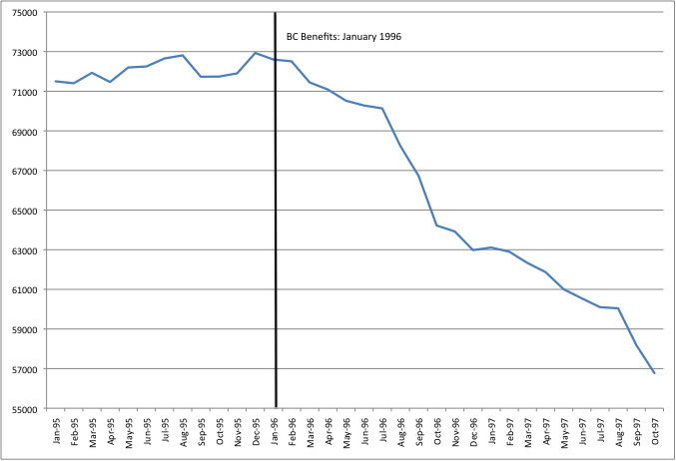

**Figure 3: IA Rates in British Columbia – Early vs. Later Cohorts**

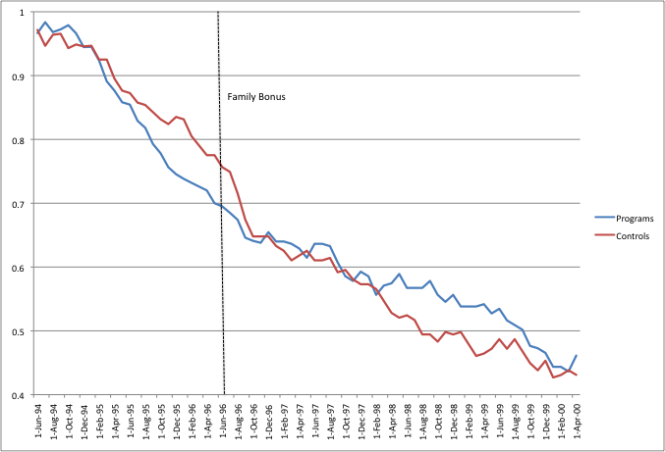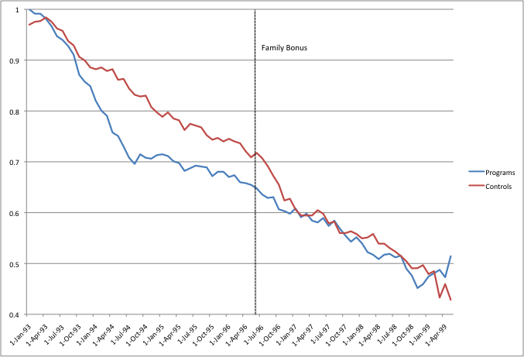

**Figure 4: Predicted IA Rates for British Columbia in the Absence of BC Benefits**

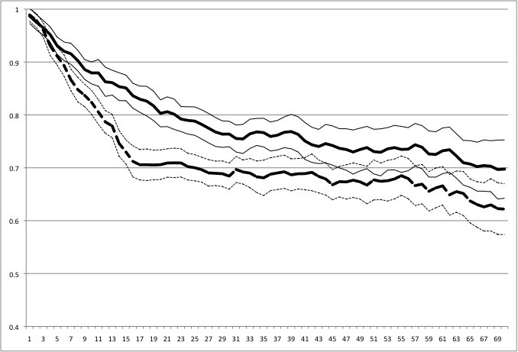

**Figure 5: IA Rates in New Brunswick in Calendar Time -- Early Cohorts**

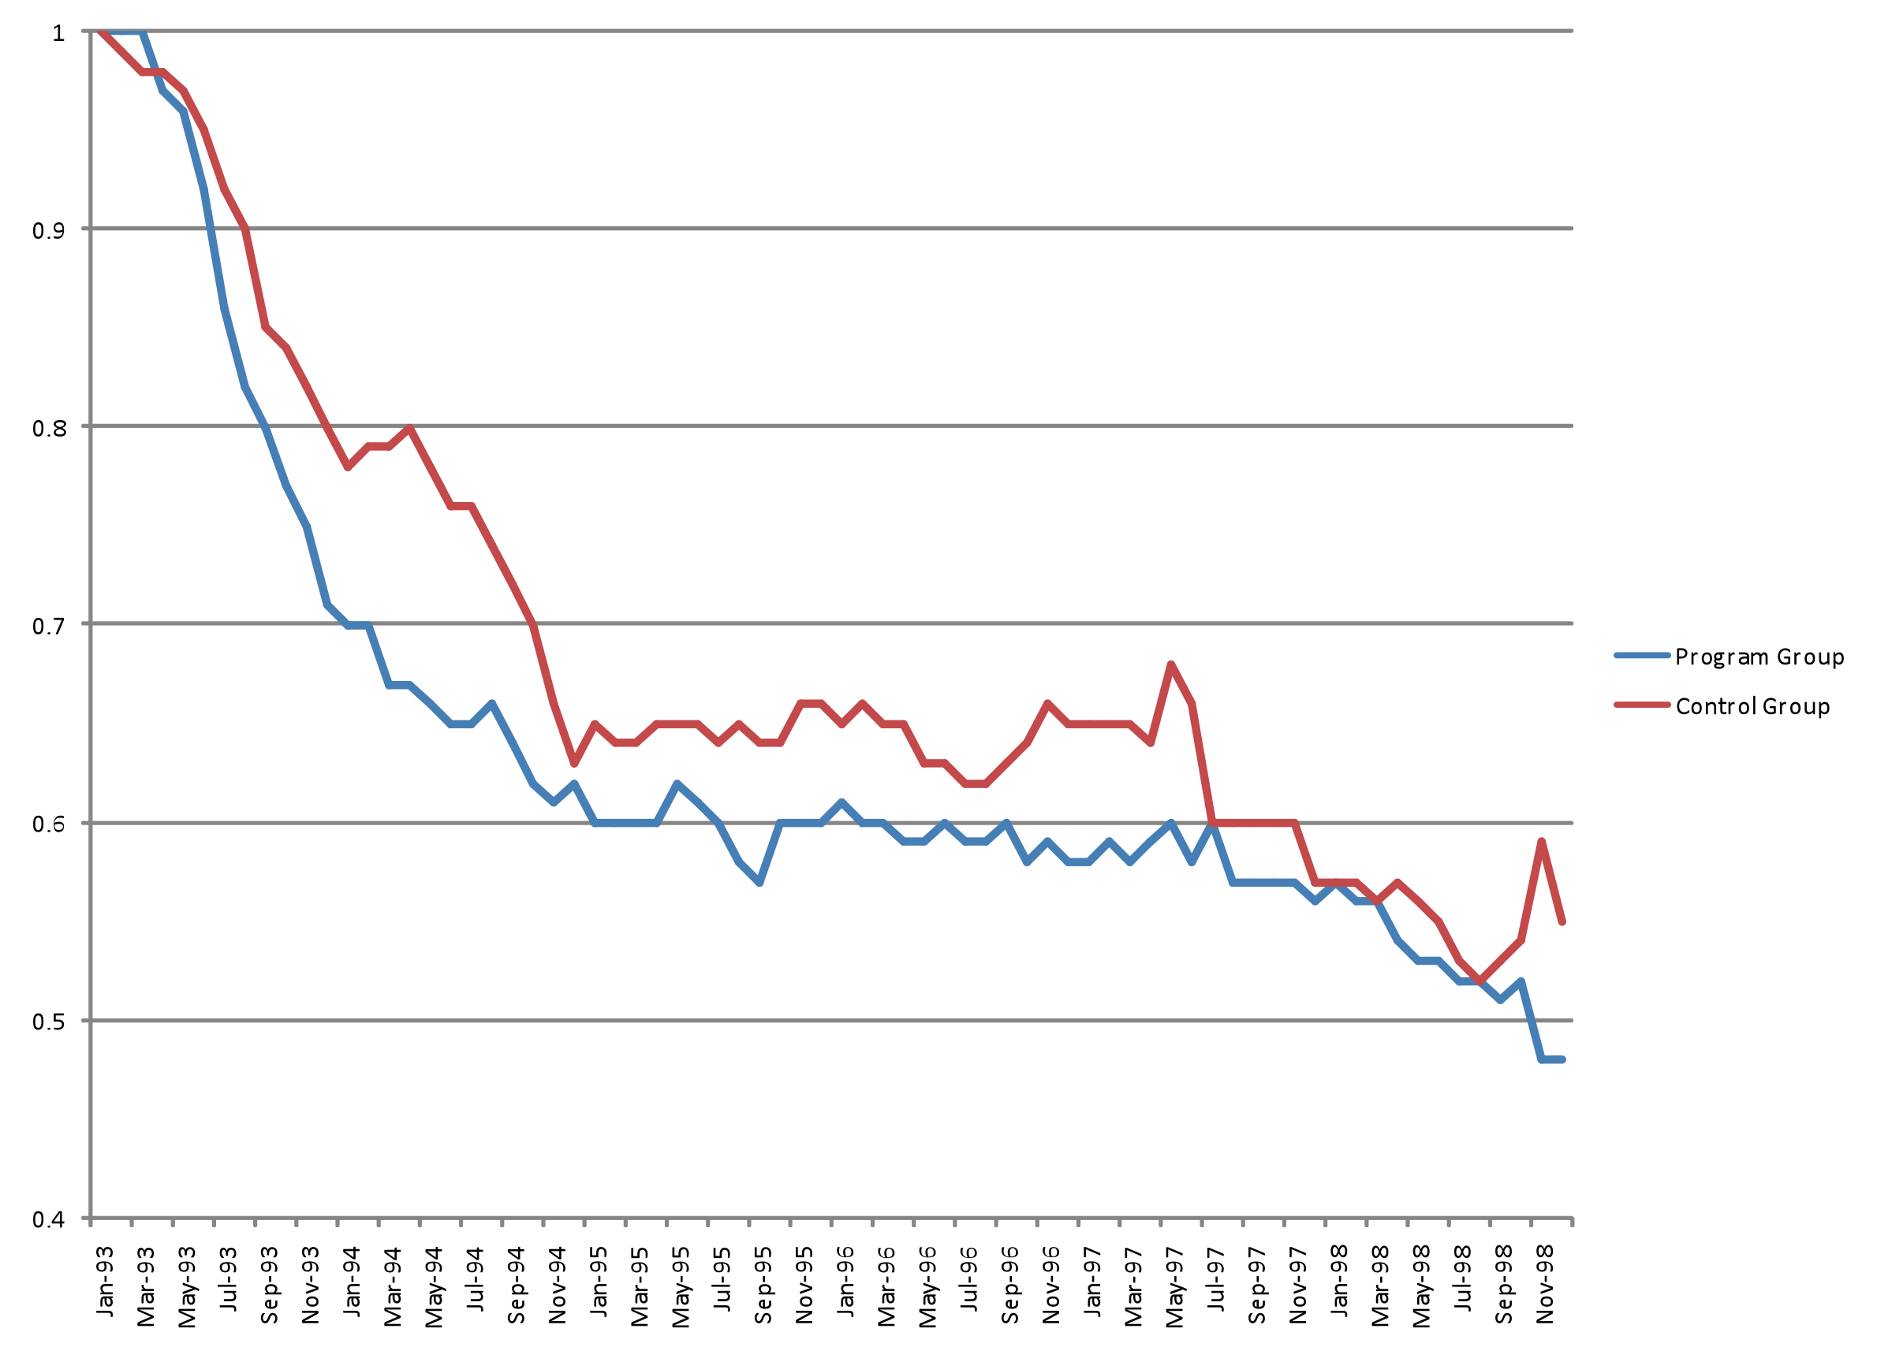

**Figure 6: IA Rates in New Brunswick in Calendar Time -- Later Cohorts**

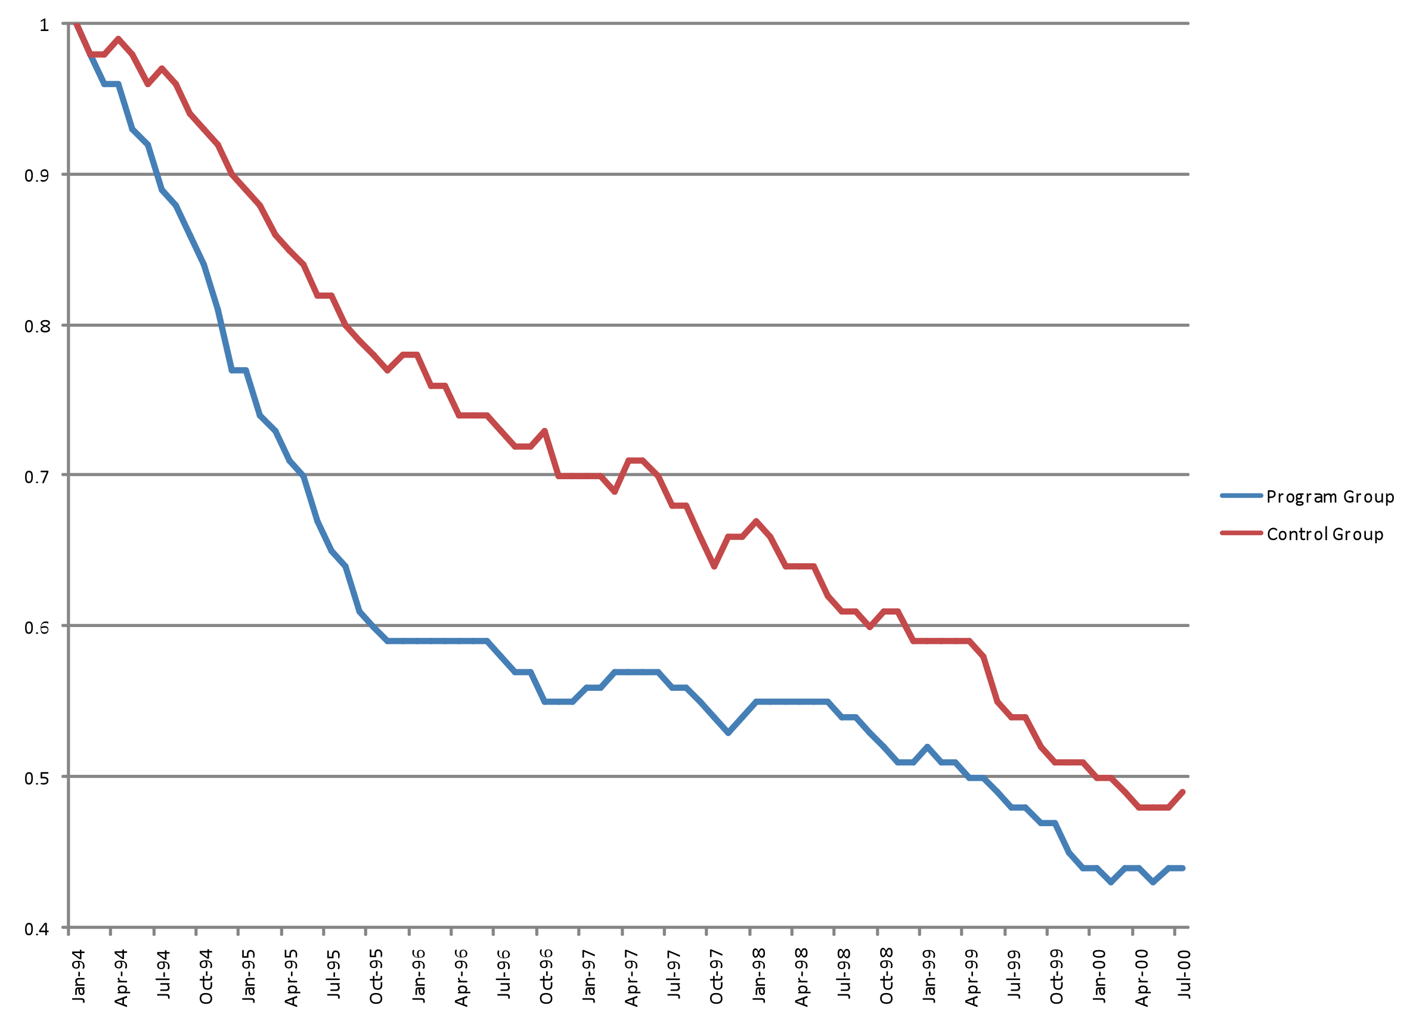

**Figure 7: Predicted IA Rates for New Brunswick’s Early Cohorts Under Program Group’s NB Works Enrolment**

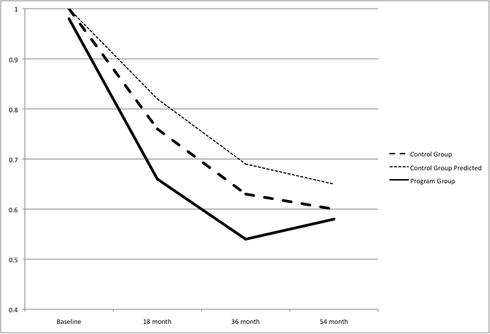

**Appendix**

**Standard SSP Figures of IA Rates over SSP ‘Time Since Onset’**

(a) B.C

(b) NB



**Distribution of observations by baseline date and province**

|  |  |  |
| --- | --- | --- |
| **Date of random assignment** | **BC** | **NB** |
| November 1992 | 0 | 89 |
| December 1992 | 0 | 94 |
| January 1993 | 84 | 99 |
| February 1993 | 221 | 111 |
| March 1993 | 246 | 105 |
| April 1993 | 240 | 111 |
| May 1993 | 237 | 41 |
| June 1993 | 201 | 30 |
| July 1993 | 91 | 0 |
| August 1993 | 86 | 0 |
| September 1993 | 11 | 0 |
| October 1993 | 1 | 0 |
| January 1994 | 125 | 128 |
| February 1994 | 118 | 133 |
| March 1994 | 127 | 154 |
| April 1994 | 128 | 153 |
| May 1994 | 143 | 126 |
| June 1994 | 124 | 129 |
| July 1994 | 131 | 127 |
| August 1994 | 134 | 133 |
| September 1994 | 142 | 151 |
| October 1994 | 144 | 149 |
| November 1994 | 152 | 184 |
| December 1994 | 112 | 183 |
| January 1995 | 15 | 172 |
| February 1995 | 10 | 180 |
| March 1995 | 0 | 173 |
| **Total SSP observations** | **3023** | **2955** |
| **Total 1993 cohort** | **1229** | **497** |
| **Total 1994 cohort** | **1580** | **1750** |

1. The policy change at time t* may also influence the probability of re-entry on to welfare. This effect on the re-entry rate could also differ between the experimental treatment and control groups because of differences in the characteristics of the two groups at time t*.
2. Earnings disregards refer to market earnings that welfare recipients are allowed to receive without a reduction in their benefits.
3. For details of the SSP demonstration see the Final Report, Michalopoulos et. al (2002).
4. In Canada welfare programs are operated by the provinces, and are referred to as Income Assistance (IA) or Social Assistance (SA). IA is not restricted to families with children.
5. About three-quarters of the SSP sample had been receiving IA for more than 2 years, and more than 40% had received IA for more than 3 years.
6. Full-time employment was defined as at least 30 hours per week and could be achieved by combining two or more part-time jobs.
7. Although these changes culminated in the passage of the B.C. Benefits Act in October 1996, many important policy changes were introduced prior to the passage of the new Act through revisions to the regulations under the previous legislation governing the income assistance program.
8. Indeed, the new names for major components of the program – “Youth Works” for those age 19-24 and “Welfare to Work” for those age 25-59 made clear the shift in the intent of the program.
9. At the time of the relevant regulation this group only constitutes about 10% of the BC sample and thus we ignore these individuals.
10. Previously the enhanced disregard allowed a recipient to set aside up to 25% of earnings in excess of $200 per month in 12 of every 36 months.
11. The maximum monthly benefit of $103 per child was paid to families with incomes of $18,000 or less, decreasing to zero when income reaches $34,000 for a family with 1 or 2 children. For larger families the payments decline less rapidly.
12. See, for example, the discussion in the Final Report (Michalopoulos et. al. 2002, pp. 6-9).
13. The SSP surveys are very rich in detail but only go from the baseline to 4.5 years later (the final survey at 54 months). In contrast, the administrative data goes to 70 months, nearly 6 years post-baseline. Using the SSP surveys also limits the analysis to those who responded. In other analysis, we incorporated SSP survey data on household structure – in particular, changes over time in dependents and marital status – as the data also contains specific dates for changes in household composition (although only until the 54 month point). However, changes in household composition have no effect on our results, and thus it seems clear that using the full 70 months of administrative data is the appropriate choice.
14. Footnote on how NB welfare system is heavy in to the case officer.